Below are added “Try it Yourself”s Screenshots of the w3 tutorial by Aditya Desai asdesai 1222367497.

1. https://www.w3schools.com/js/tryit.asp?filename=tryjs_dom_method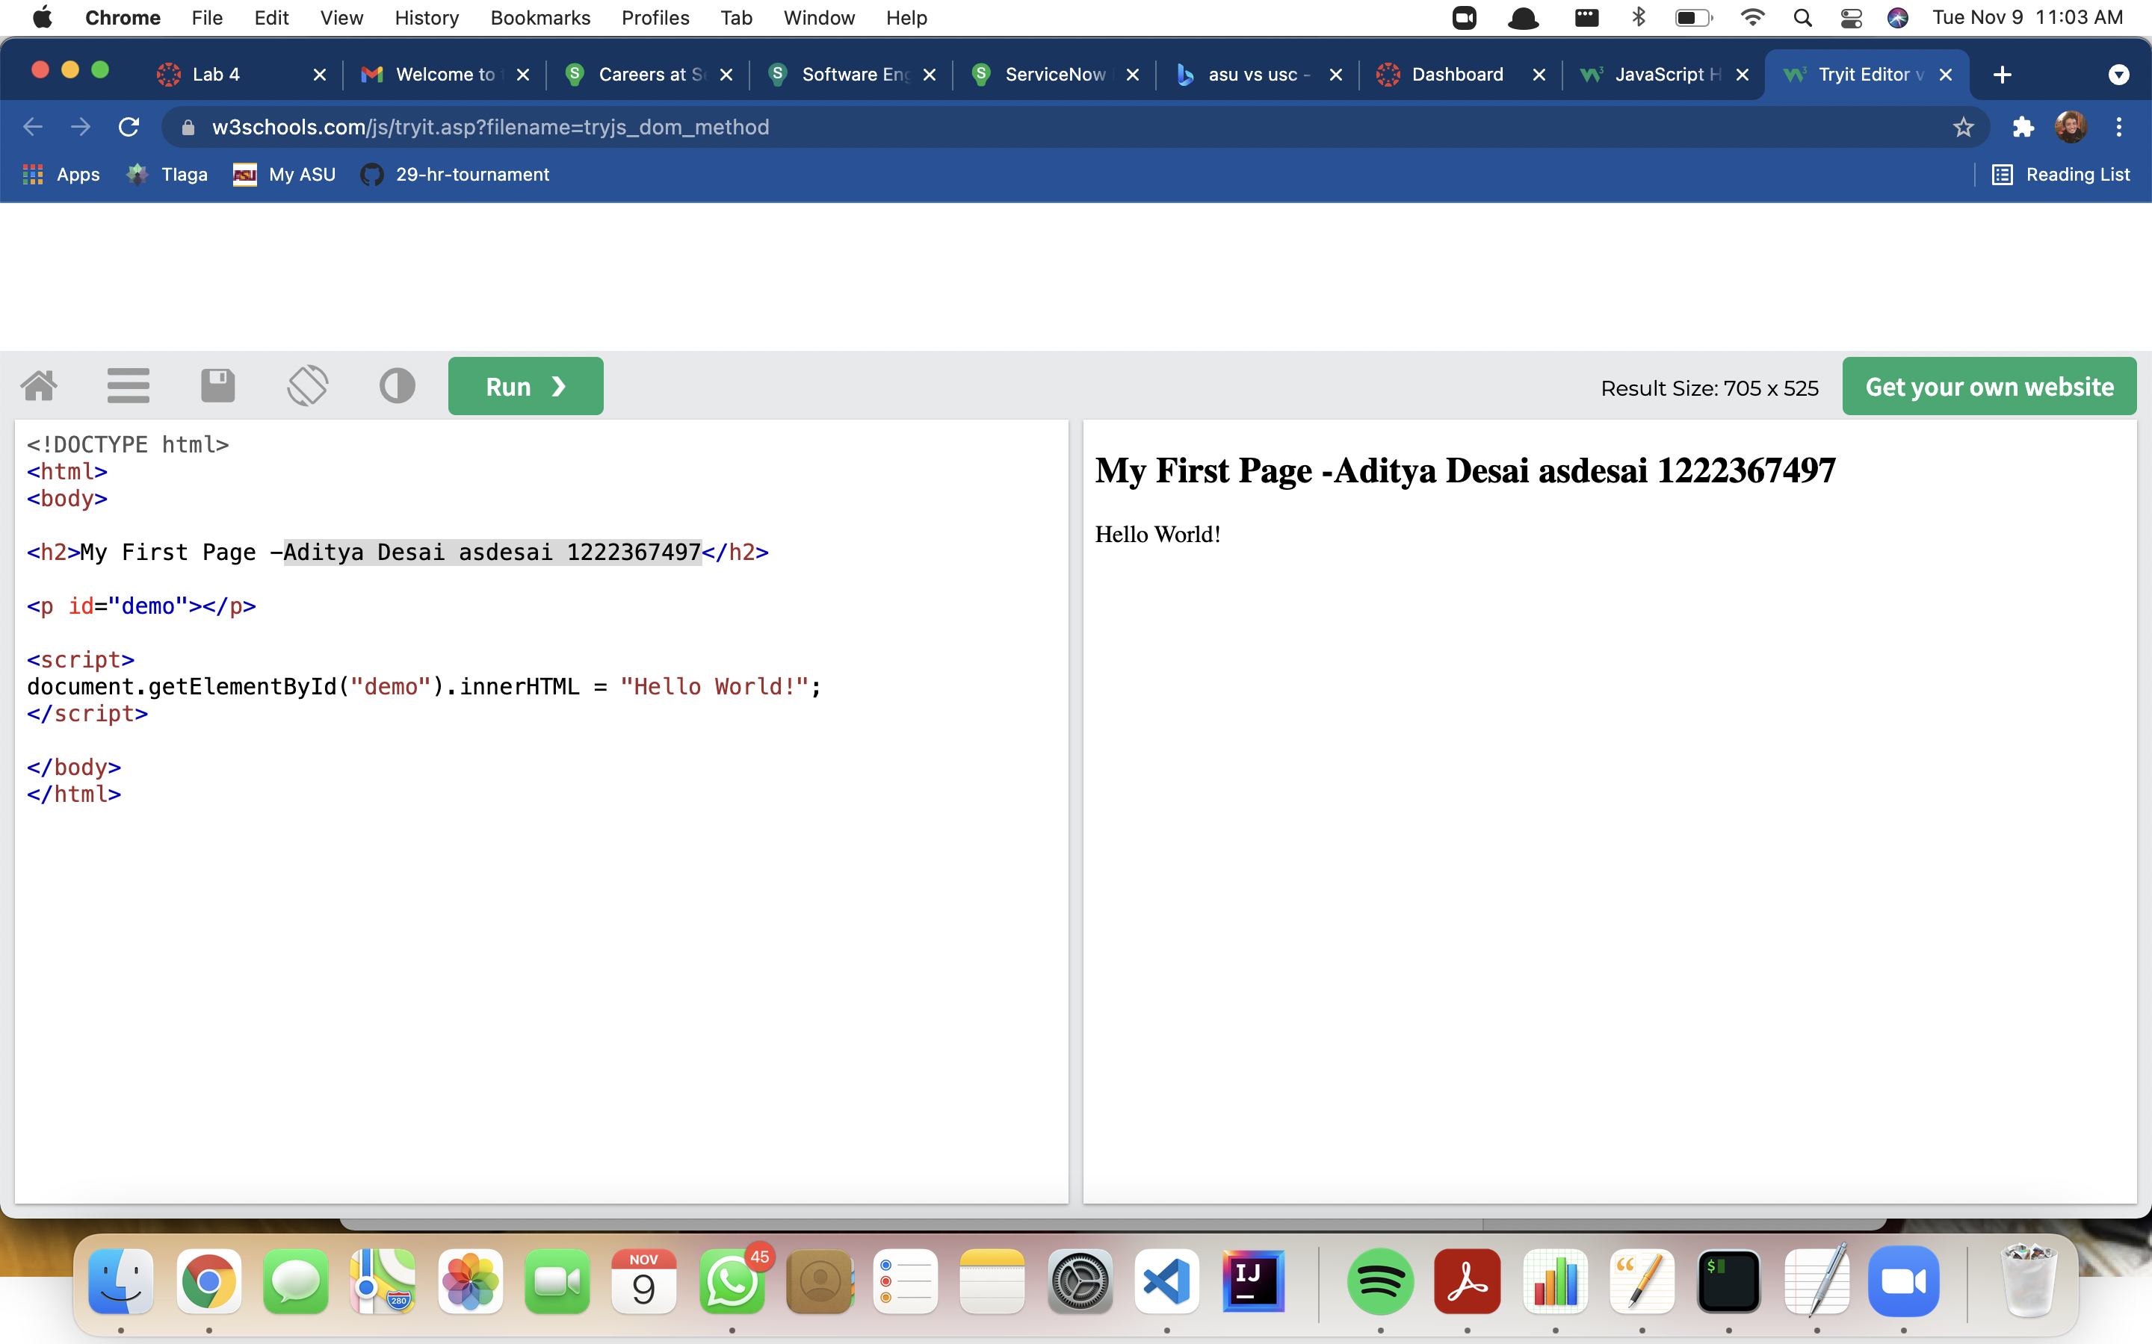

2.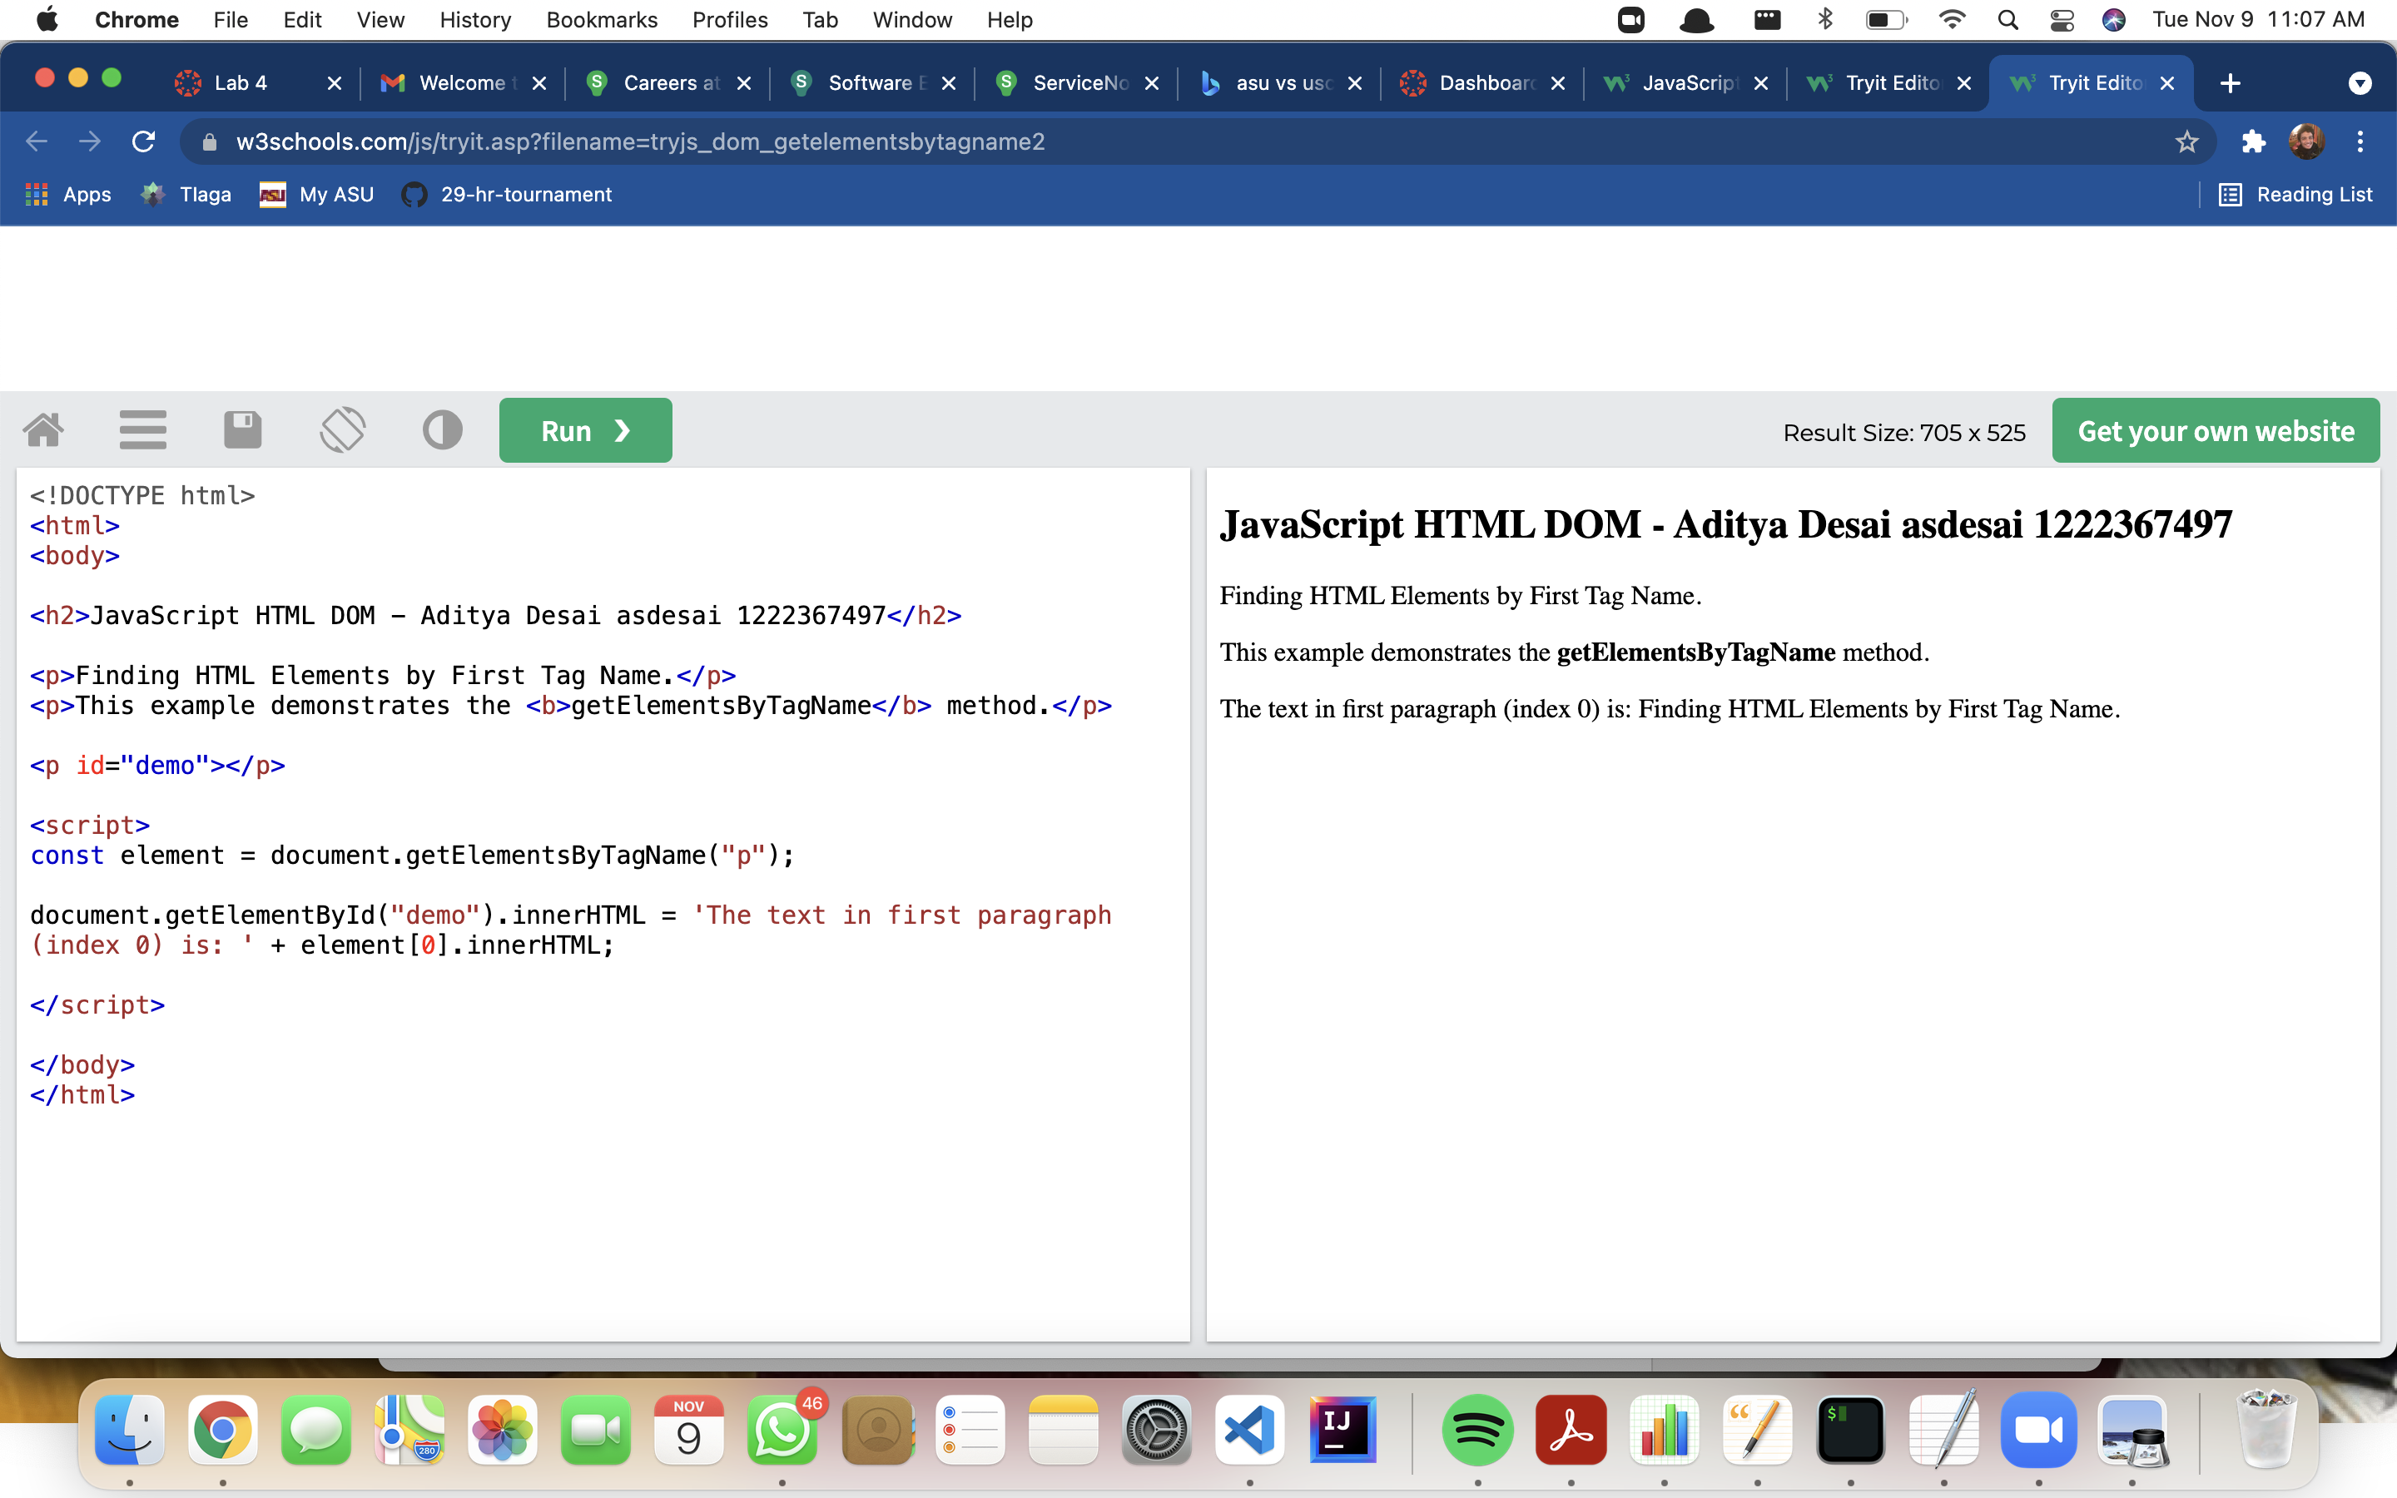 https://www.w3schools.com/js/tryit.asp?filename=tryjs_dom_getelementsbytagname2

3. <https://www.w3schools.com/js/tryit.asp?filename=tryjs_dom_getelementsbytagname>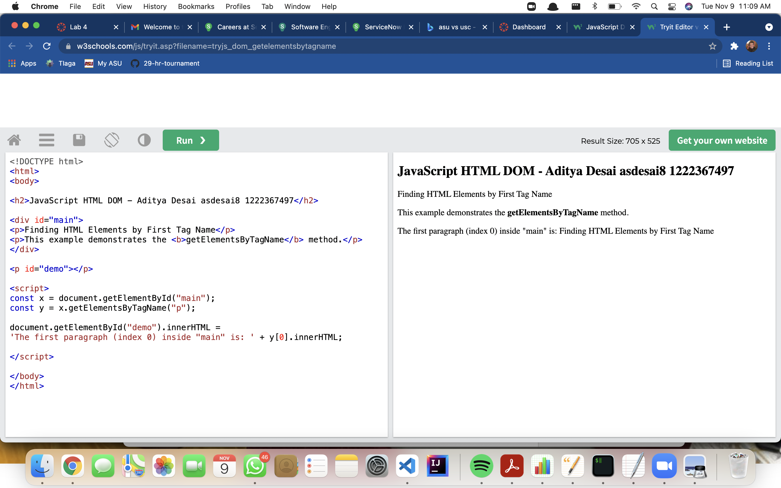

4.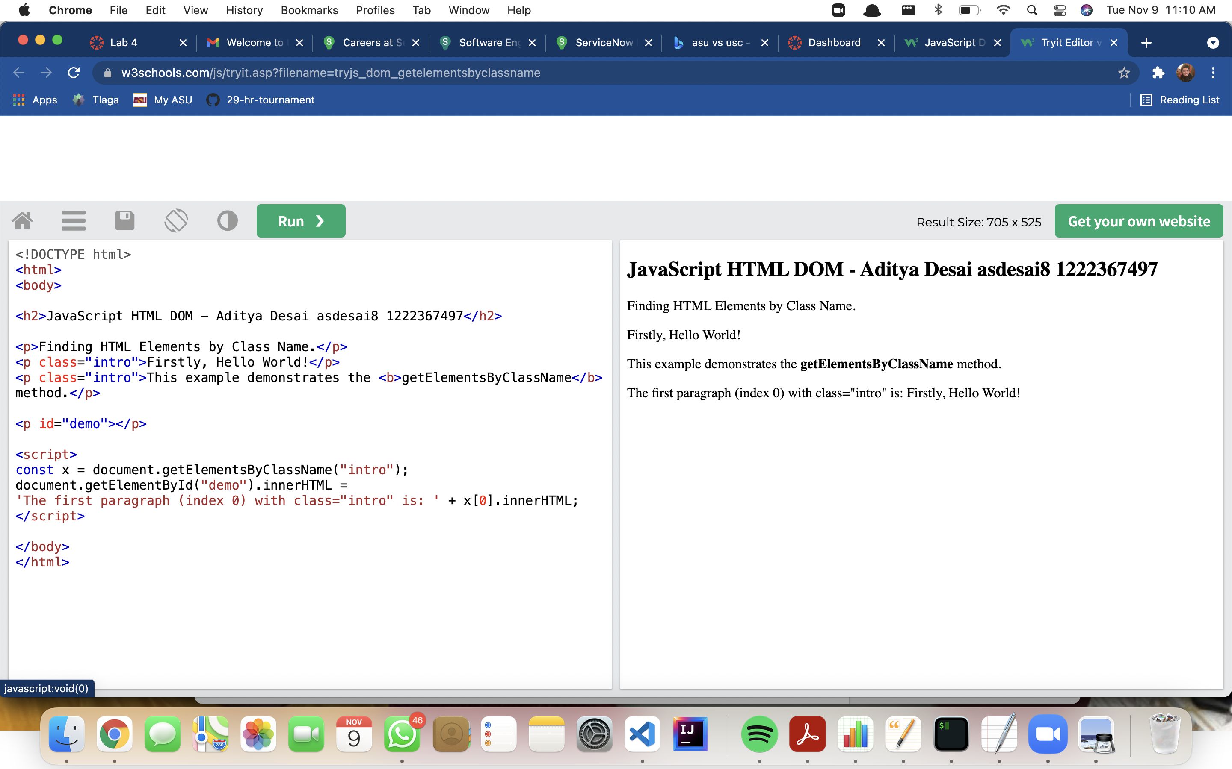 https://www.w3schools.com/js/tryit.asp?filename=tryjs_dom_getelementsbyclassname

5. <https://www.w3schools.com/js/tryit.asp?filename=tryjs_dom_queryselectorall>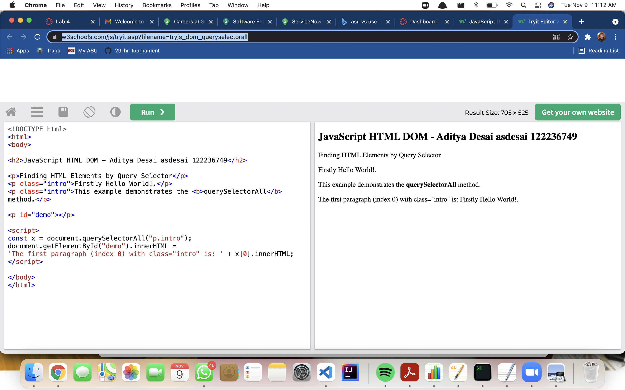

6.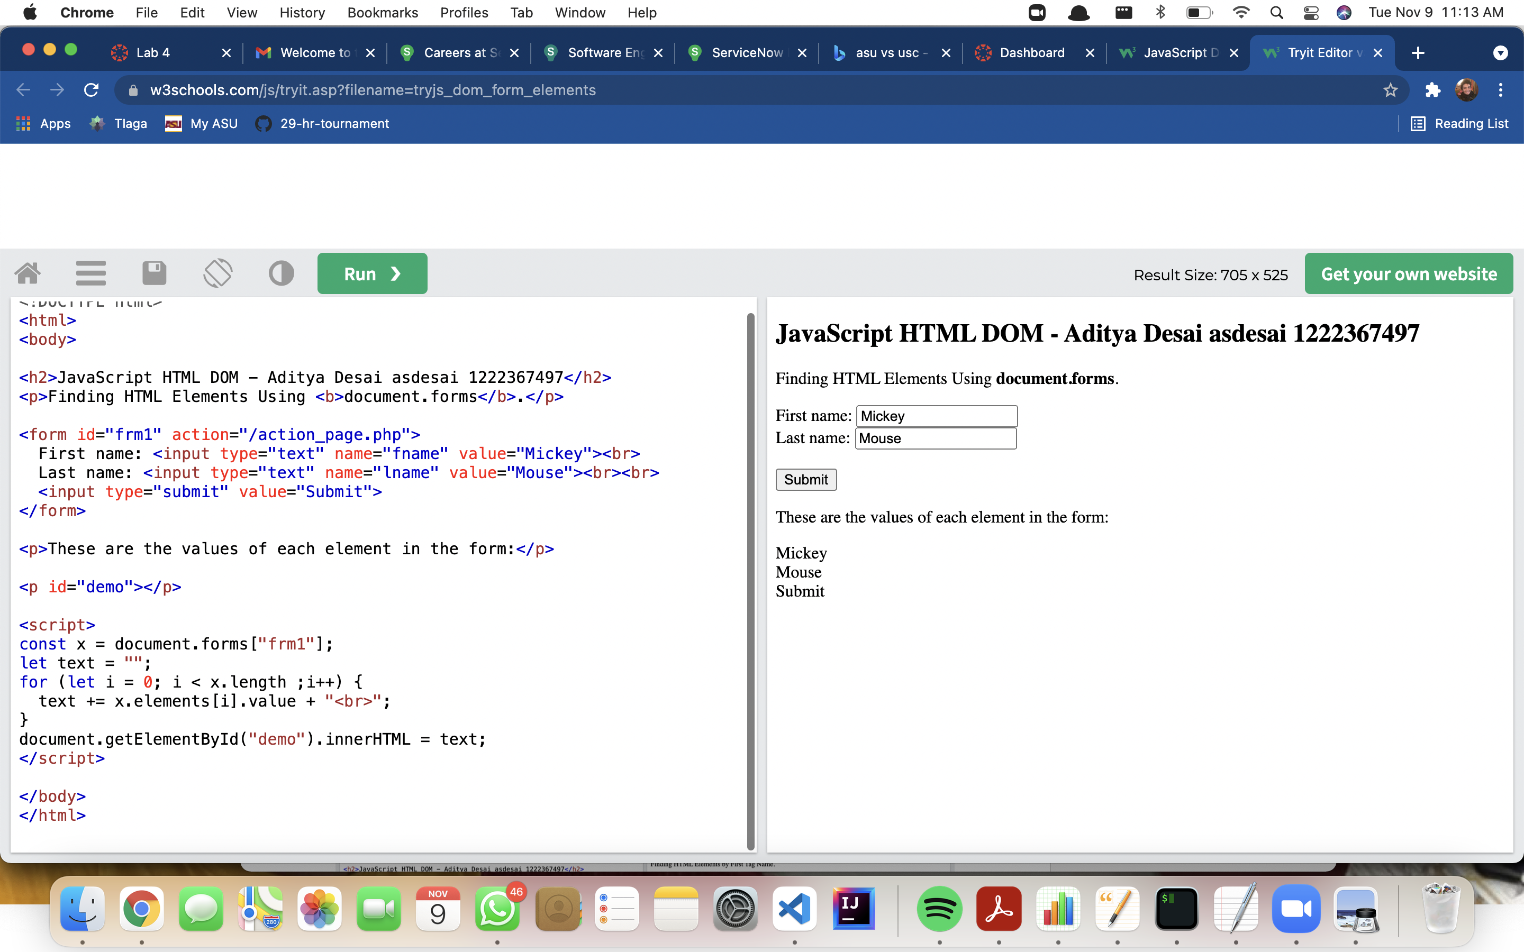 https://www.w3schools.com/js/tryit.asp?filename=tryjs_dom_form_elements

7. <https://www.w3schools.com/js/tryit.asp?filename=tryjs_change_innerhtml>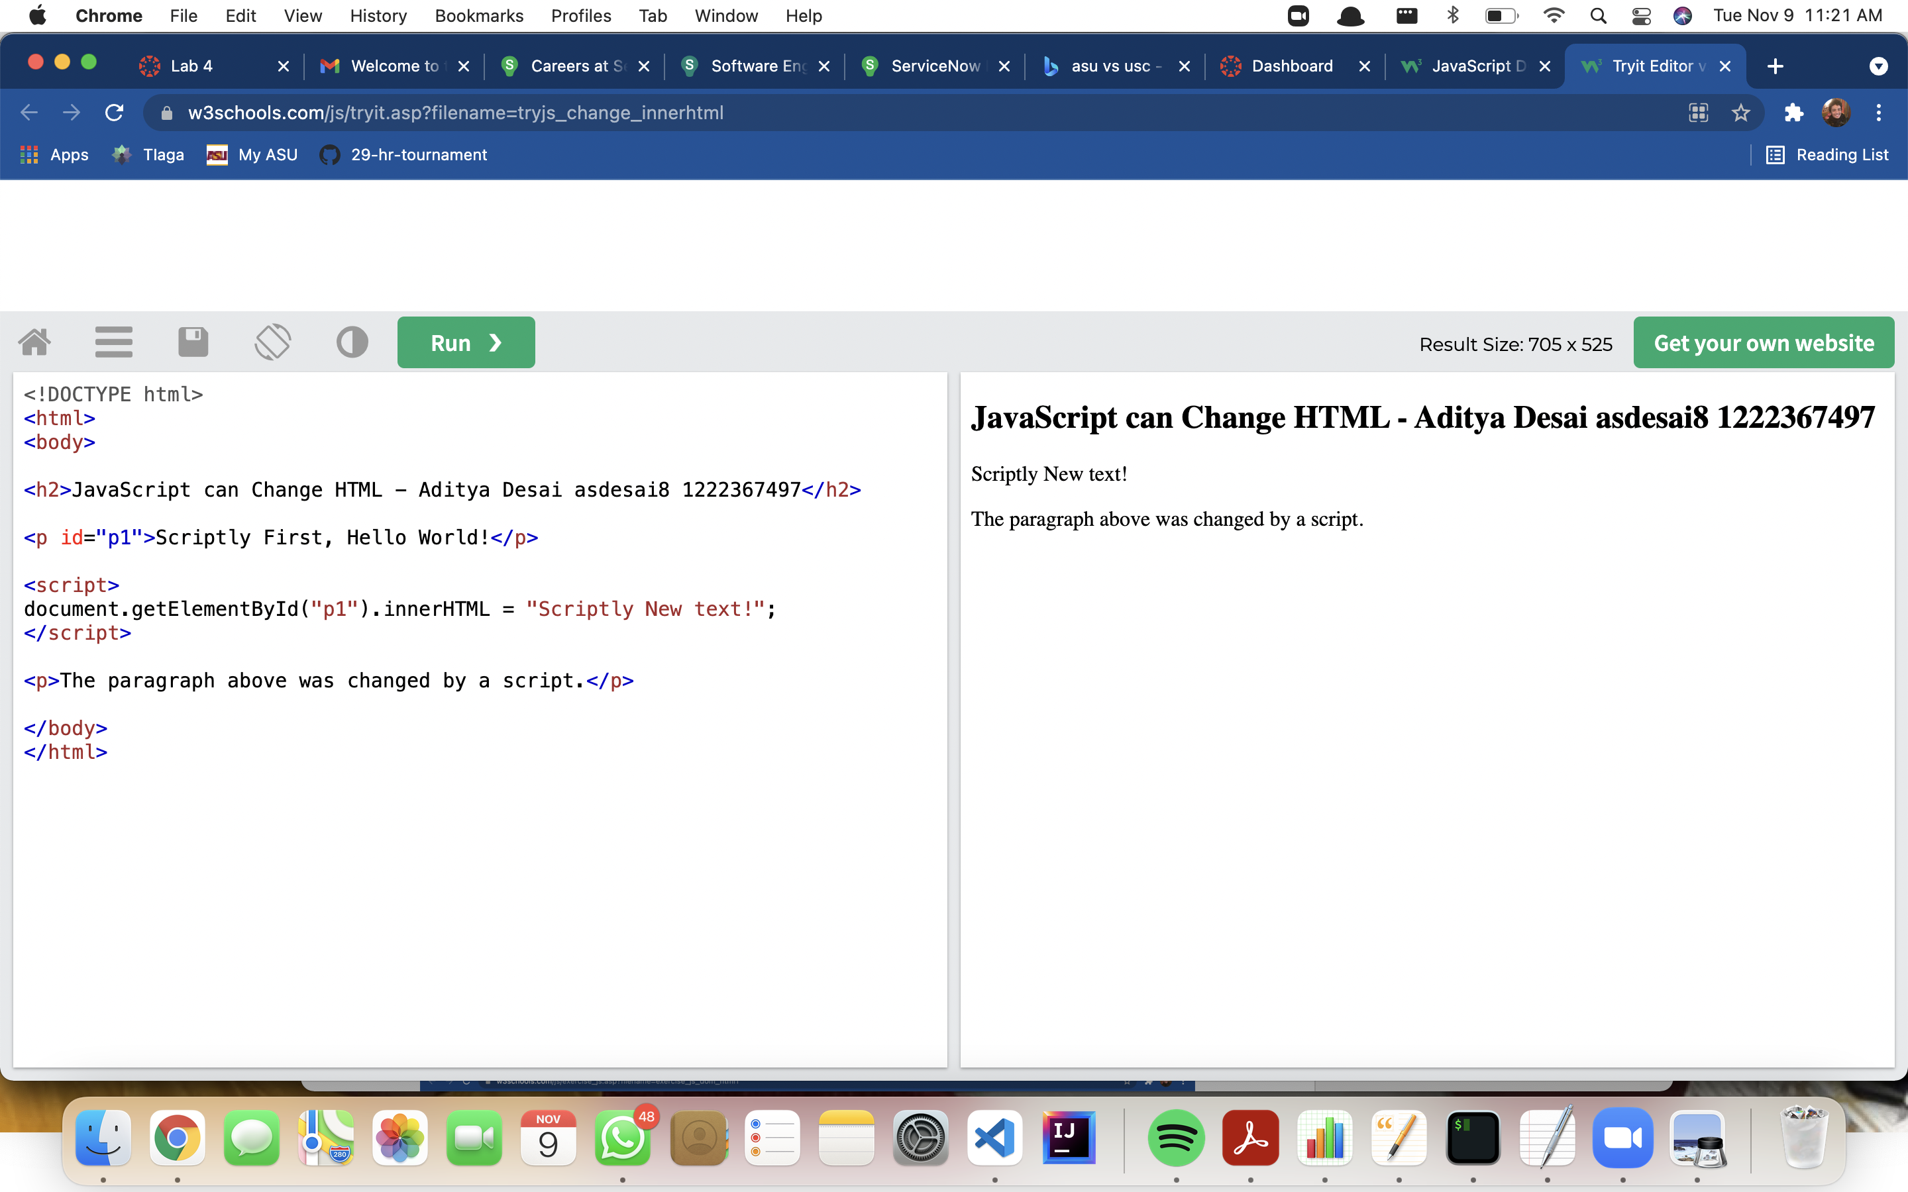

8. <https://www.w3schools.com/js/tryit.asp?filename=tryjs_dom_innerhtml>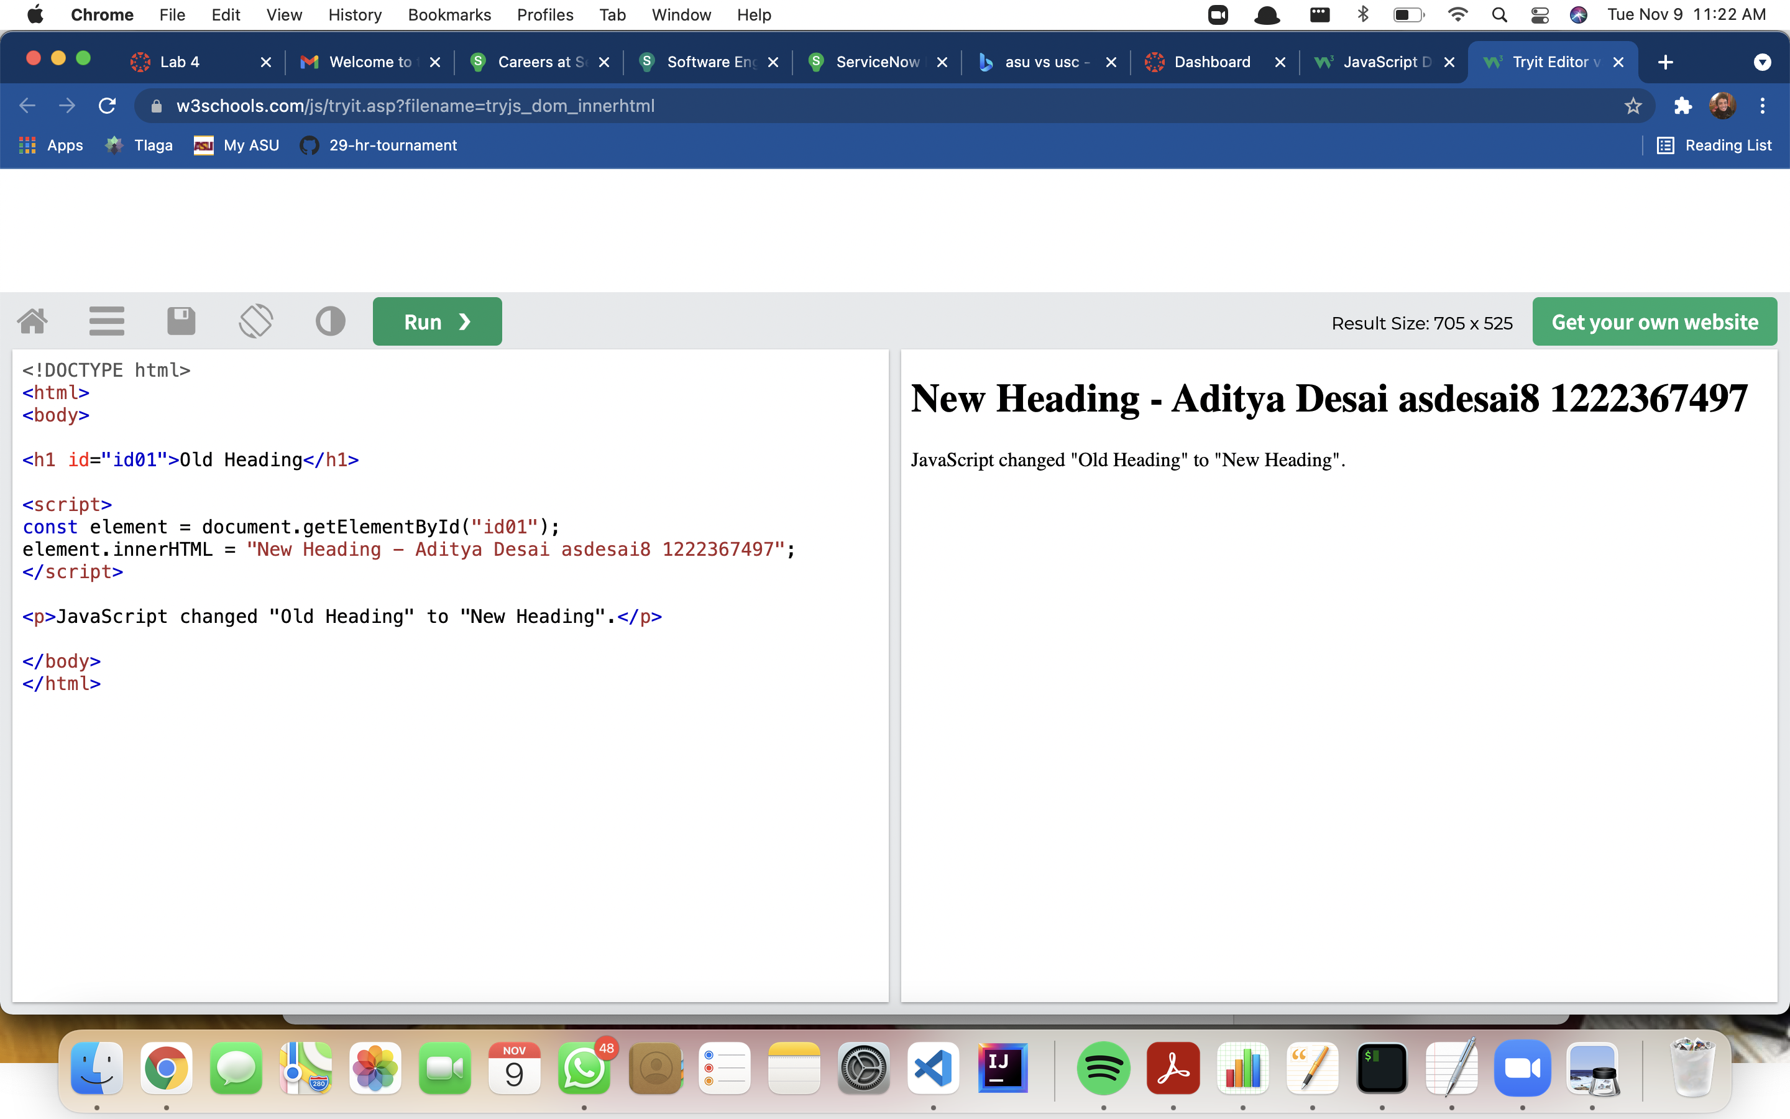

9.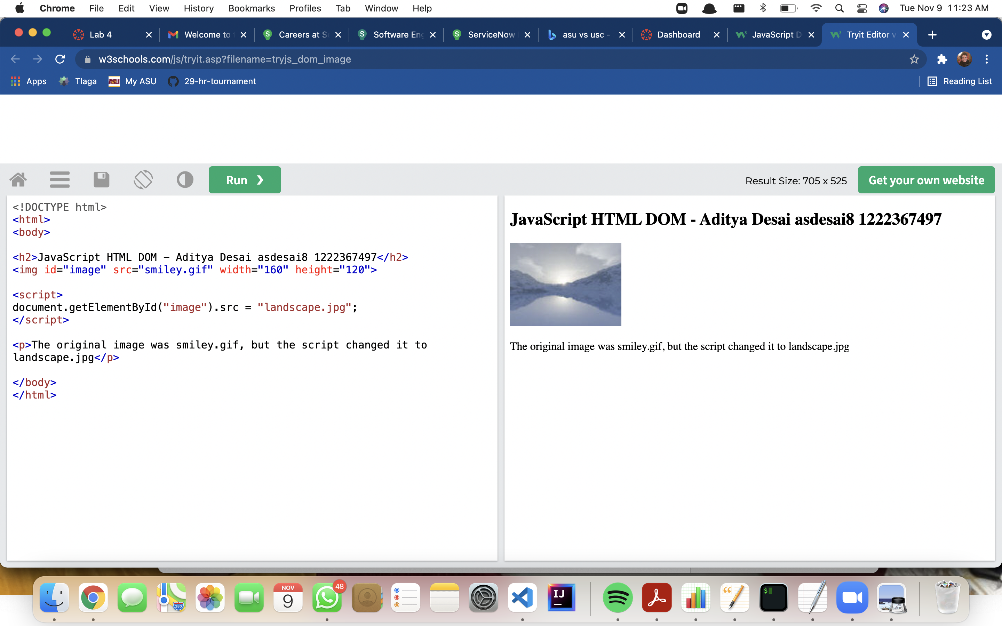 https://www.w3schools.com/js/tryit.asp?filename=tryjs_dom_image

10.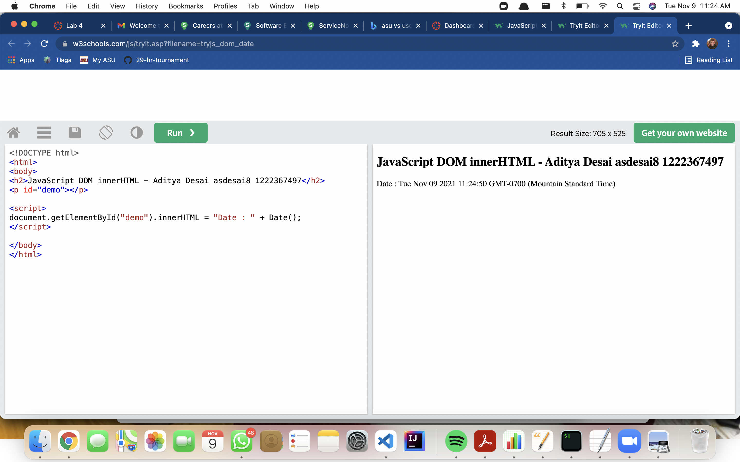 https://www.w3schools.com/js/tryit.asp?filename=tryjs_dom_date

11.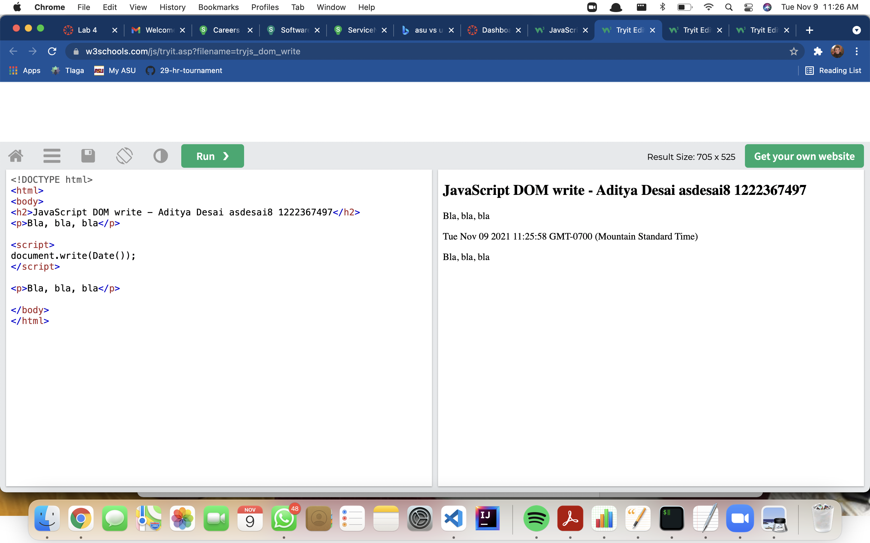 https://www.w3schools.com/js/tryit.asp?filename=tryjs_dom_write

12. https://www.w3schools.com/js/tryit.asp?filename=tryjs_validation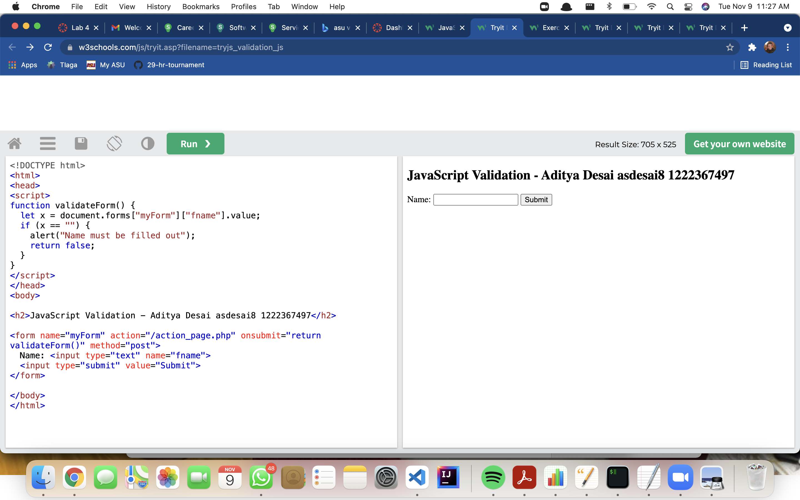

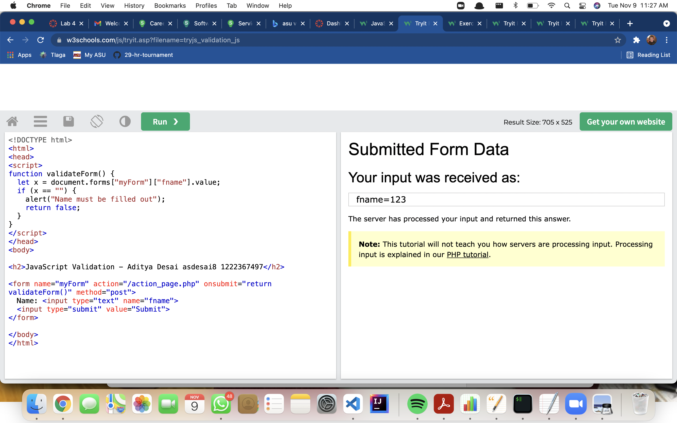

13. https://www.w3schools.com/js/tryit.asp?filename=tryjs_validation_number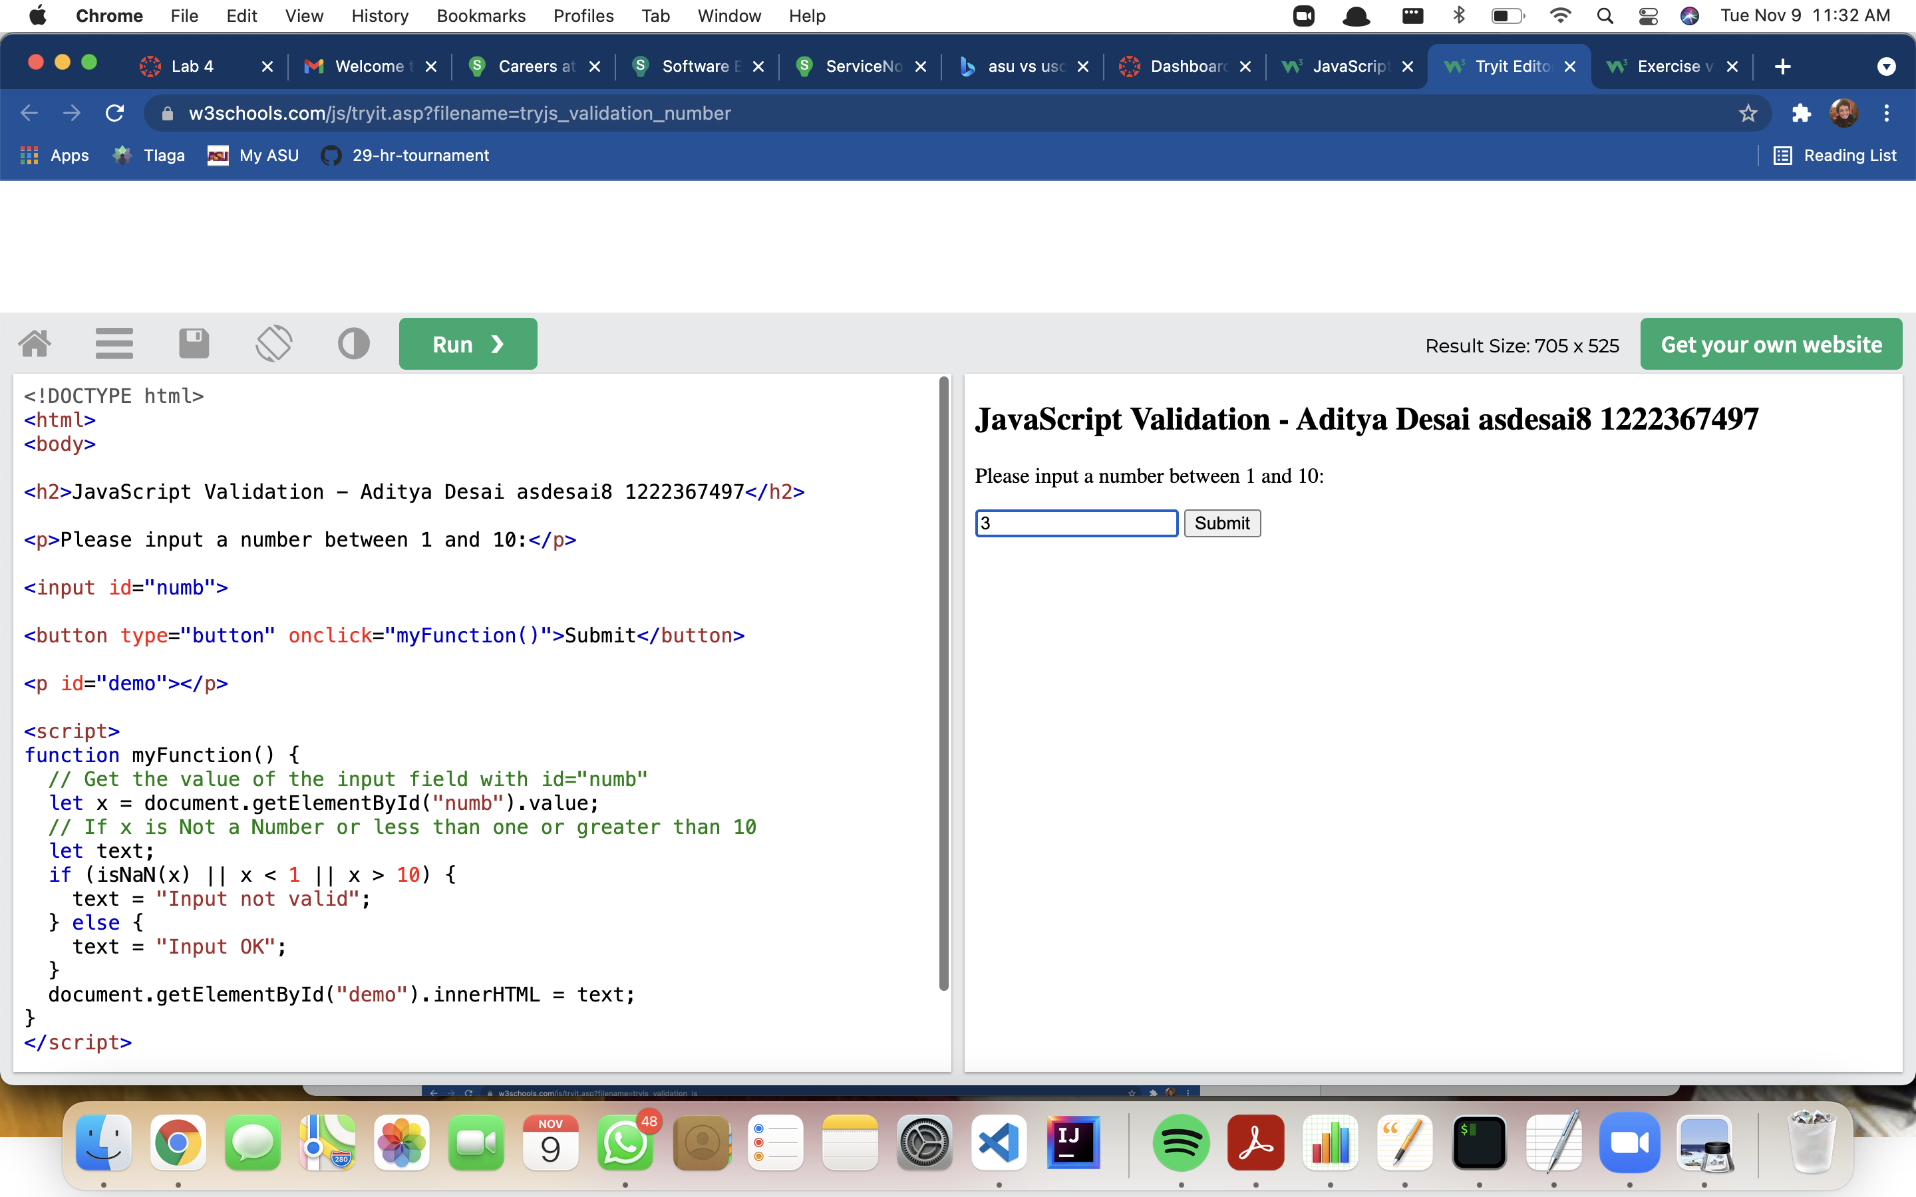

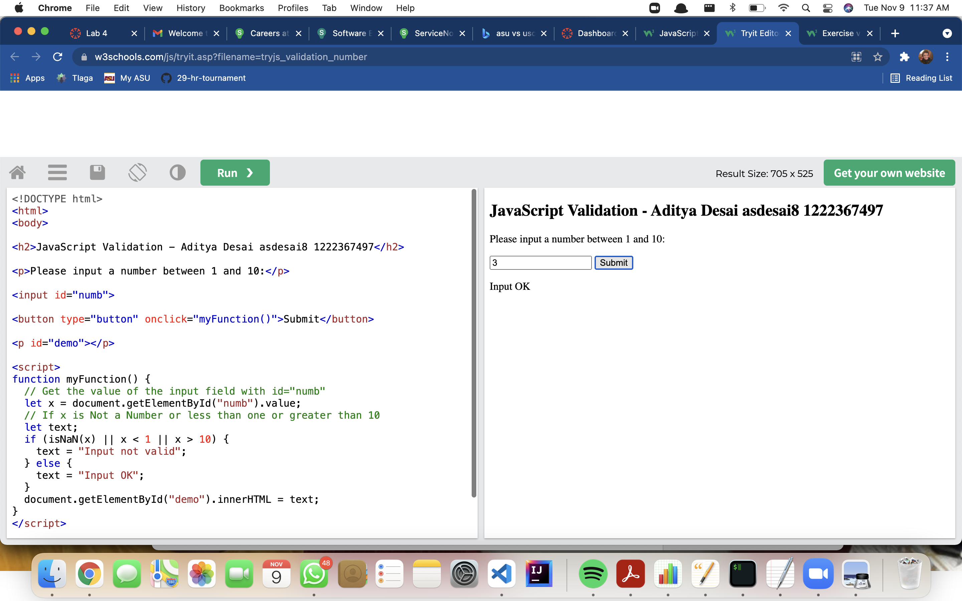

14.https://www.w3schools.com/js/tryit.asp?filename=tryjs_validation_html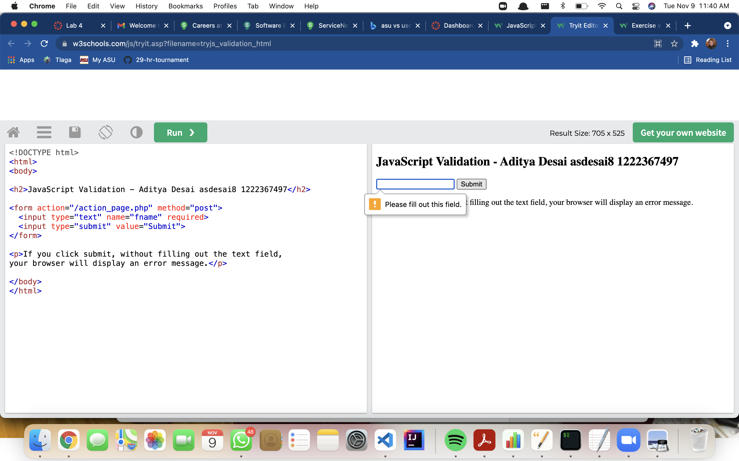

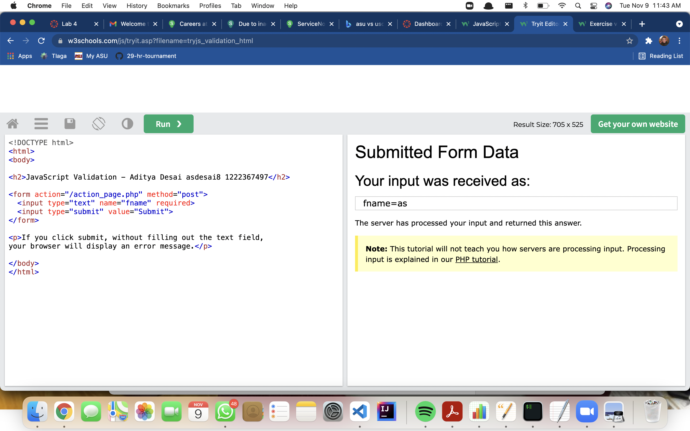

15. <https://www.w3schools.com/js/tryit.asp?filename=tryjs_dom_color2>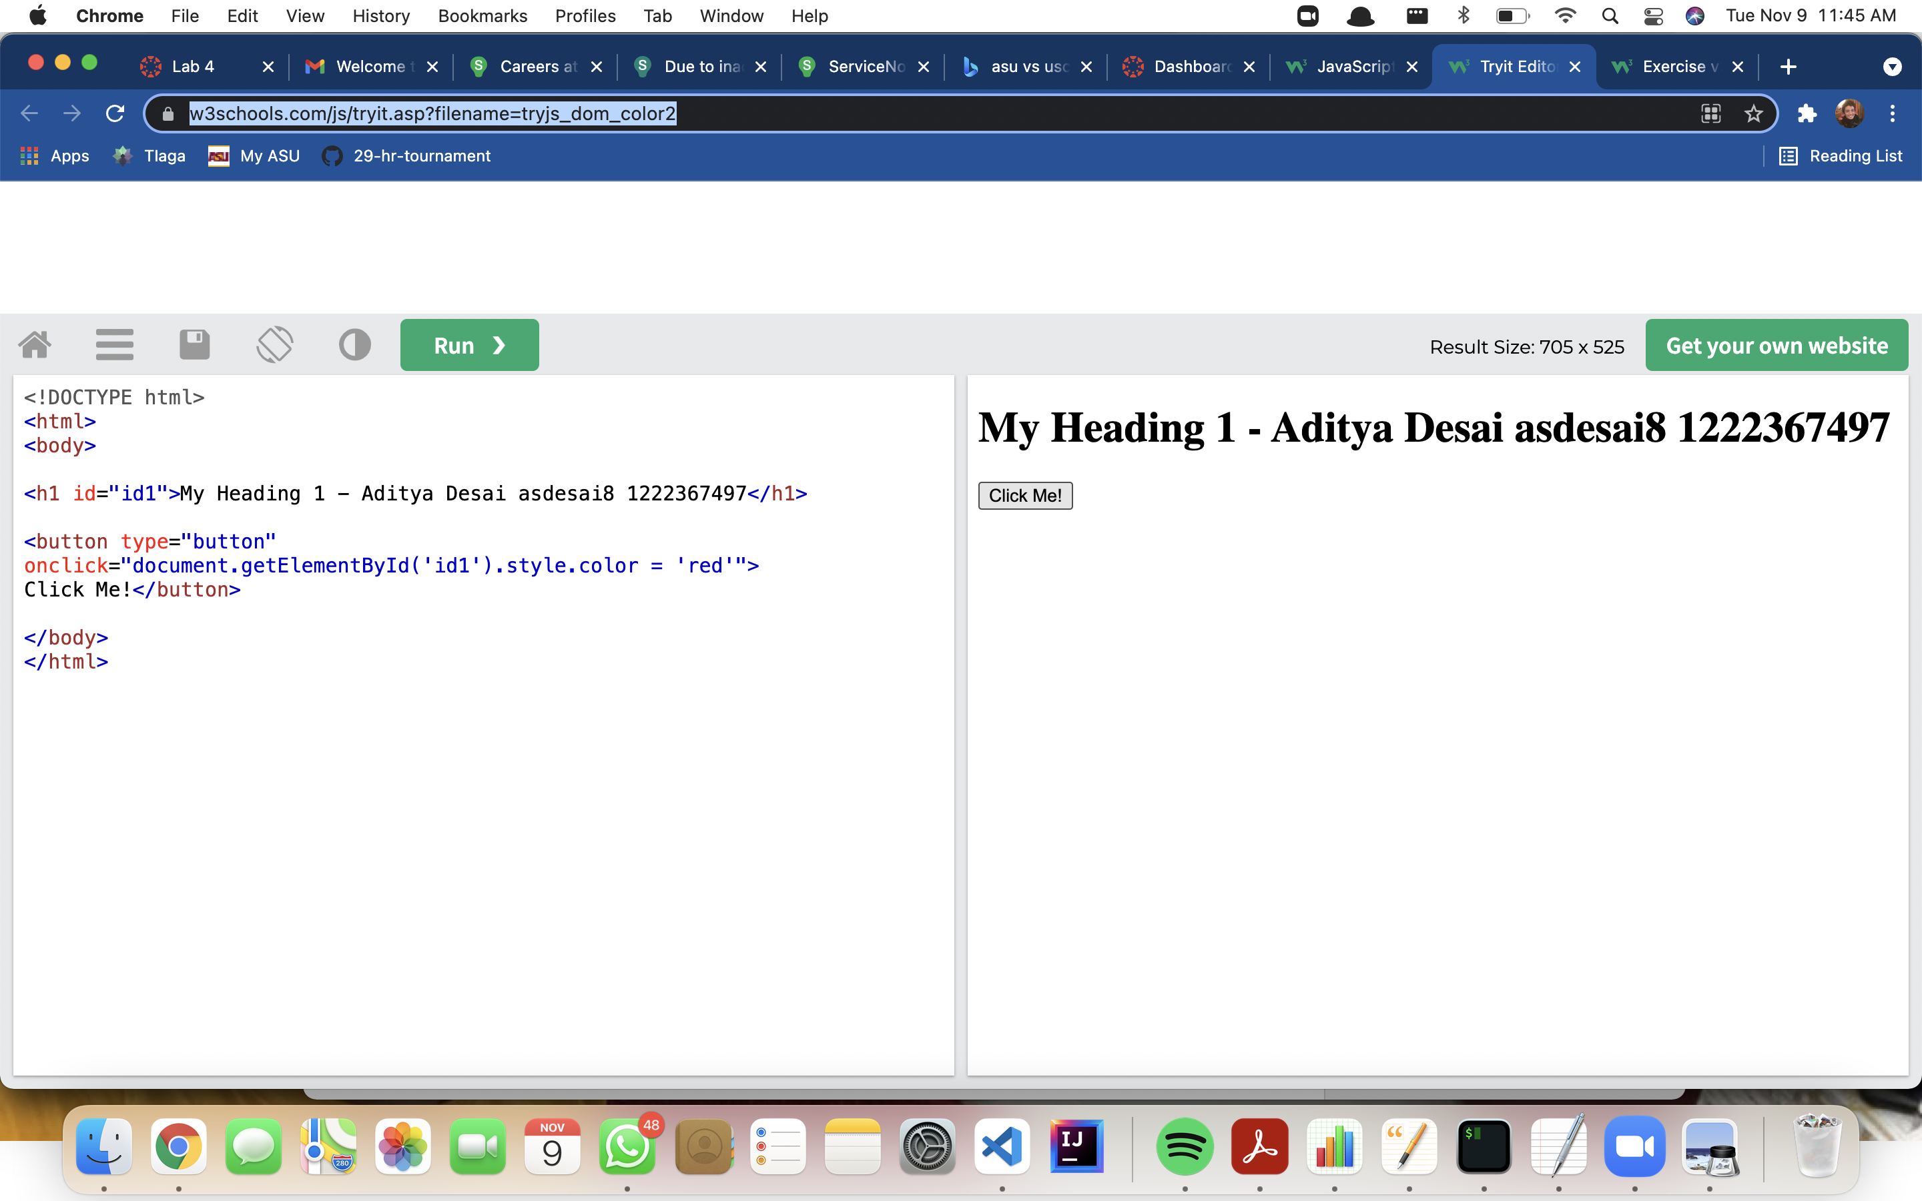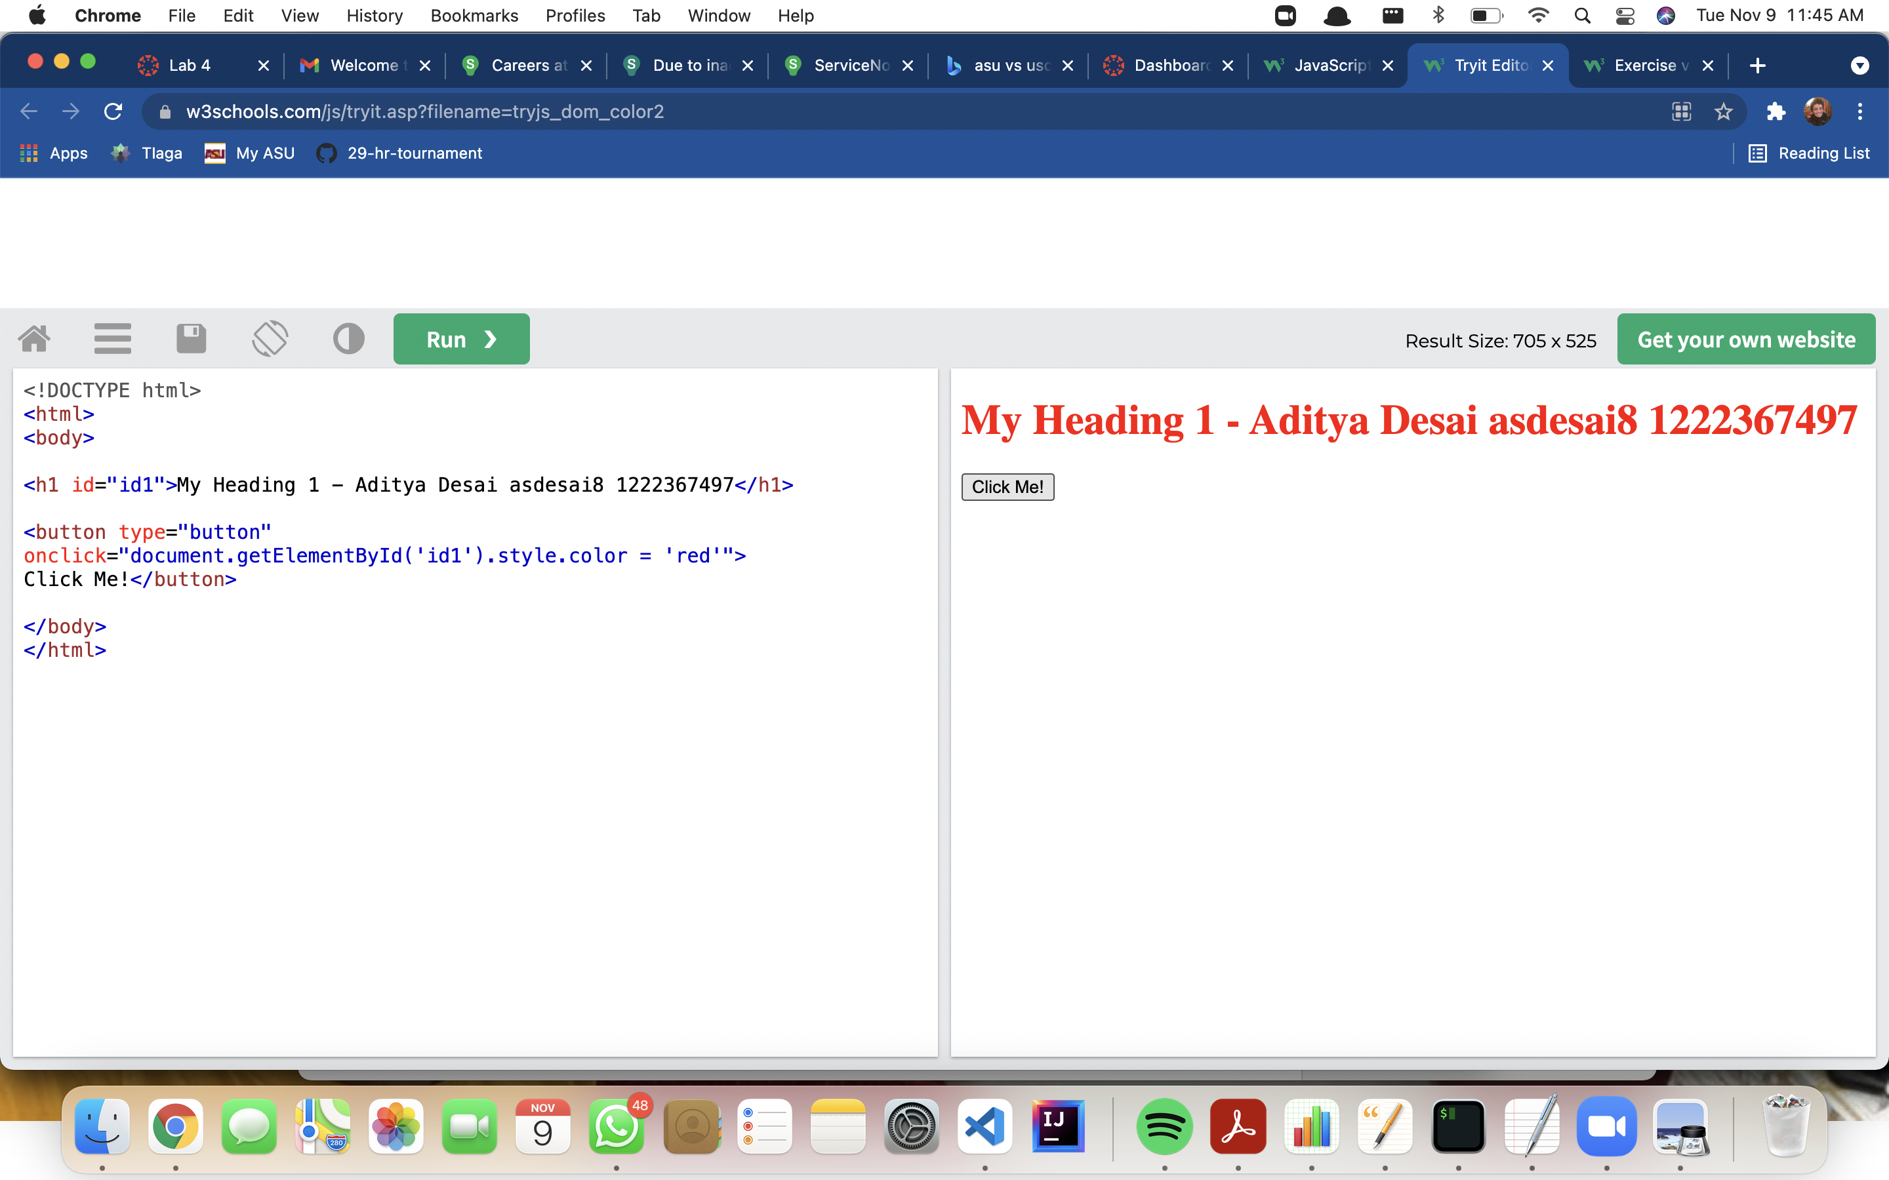

16. <https://www.w3schools.com/js/tryit.asp?filename=tryjs_dom_animate_2>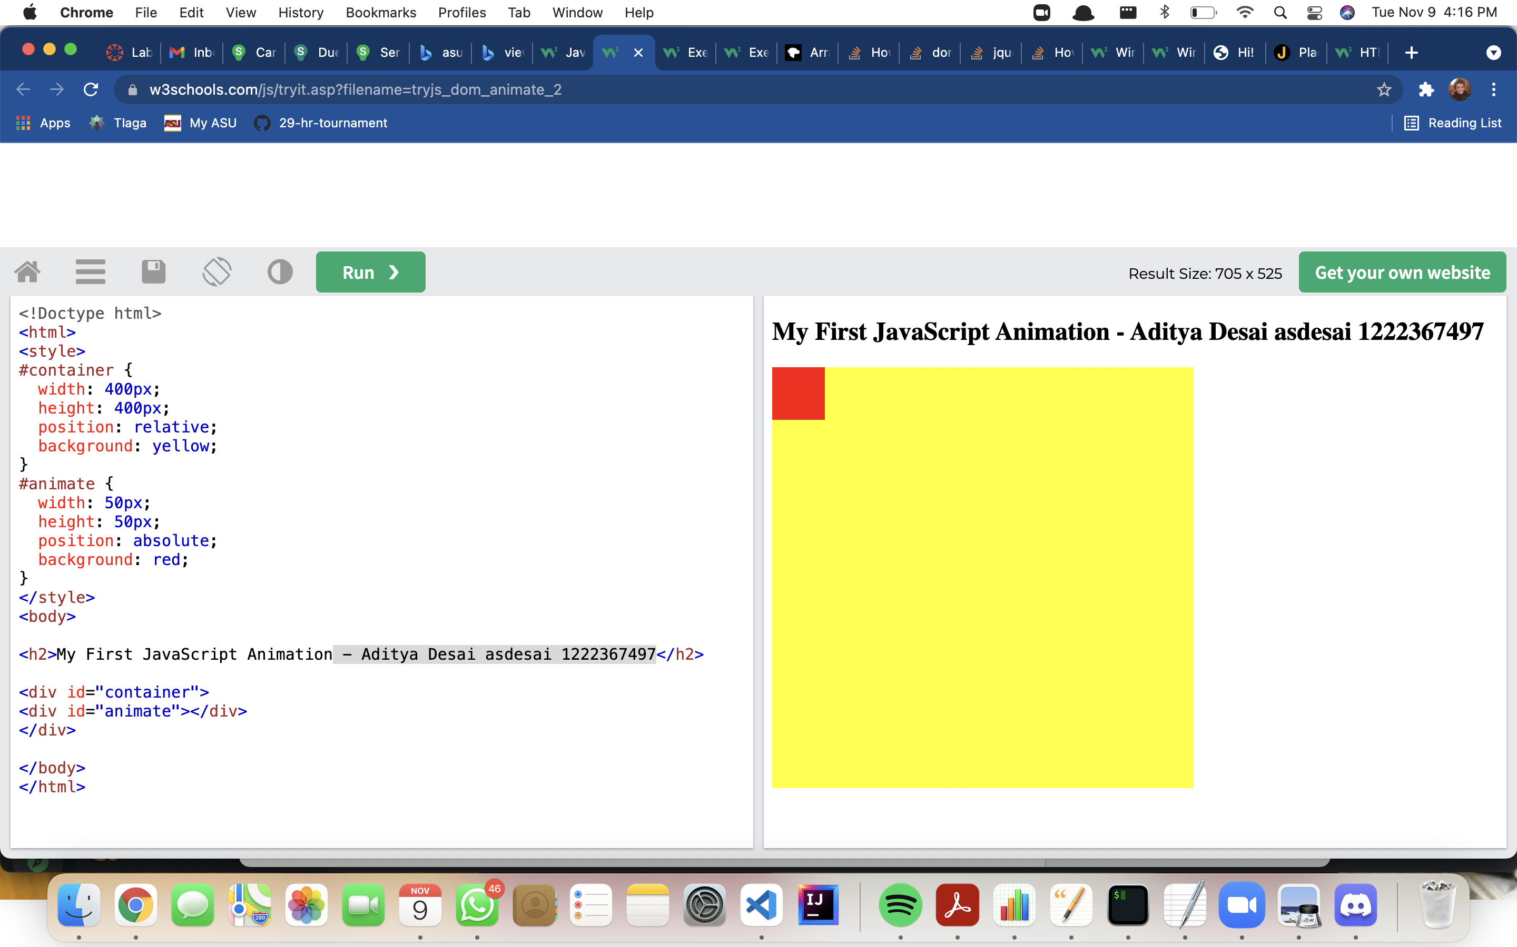

17.https://www.w3schools.com/js/tryit.asp?filename=tryjs_dom_animate_3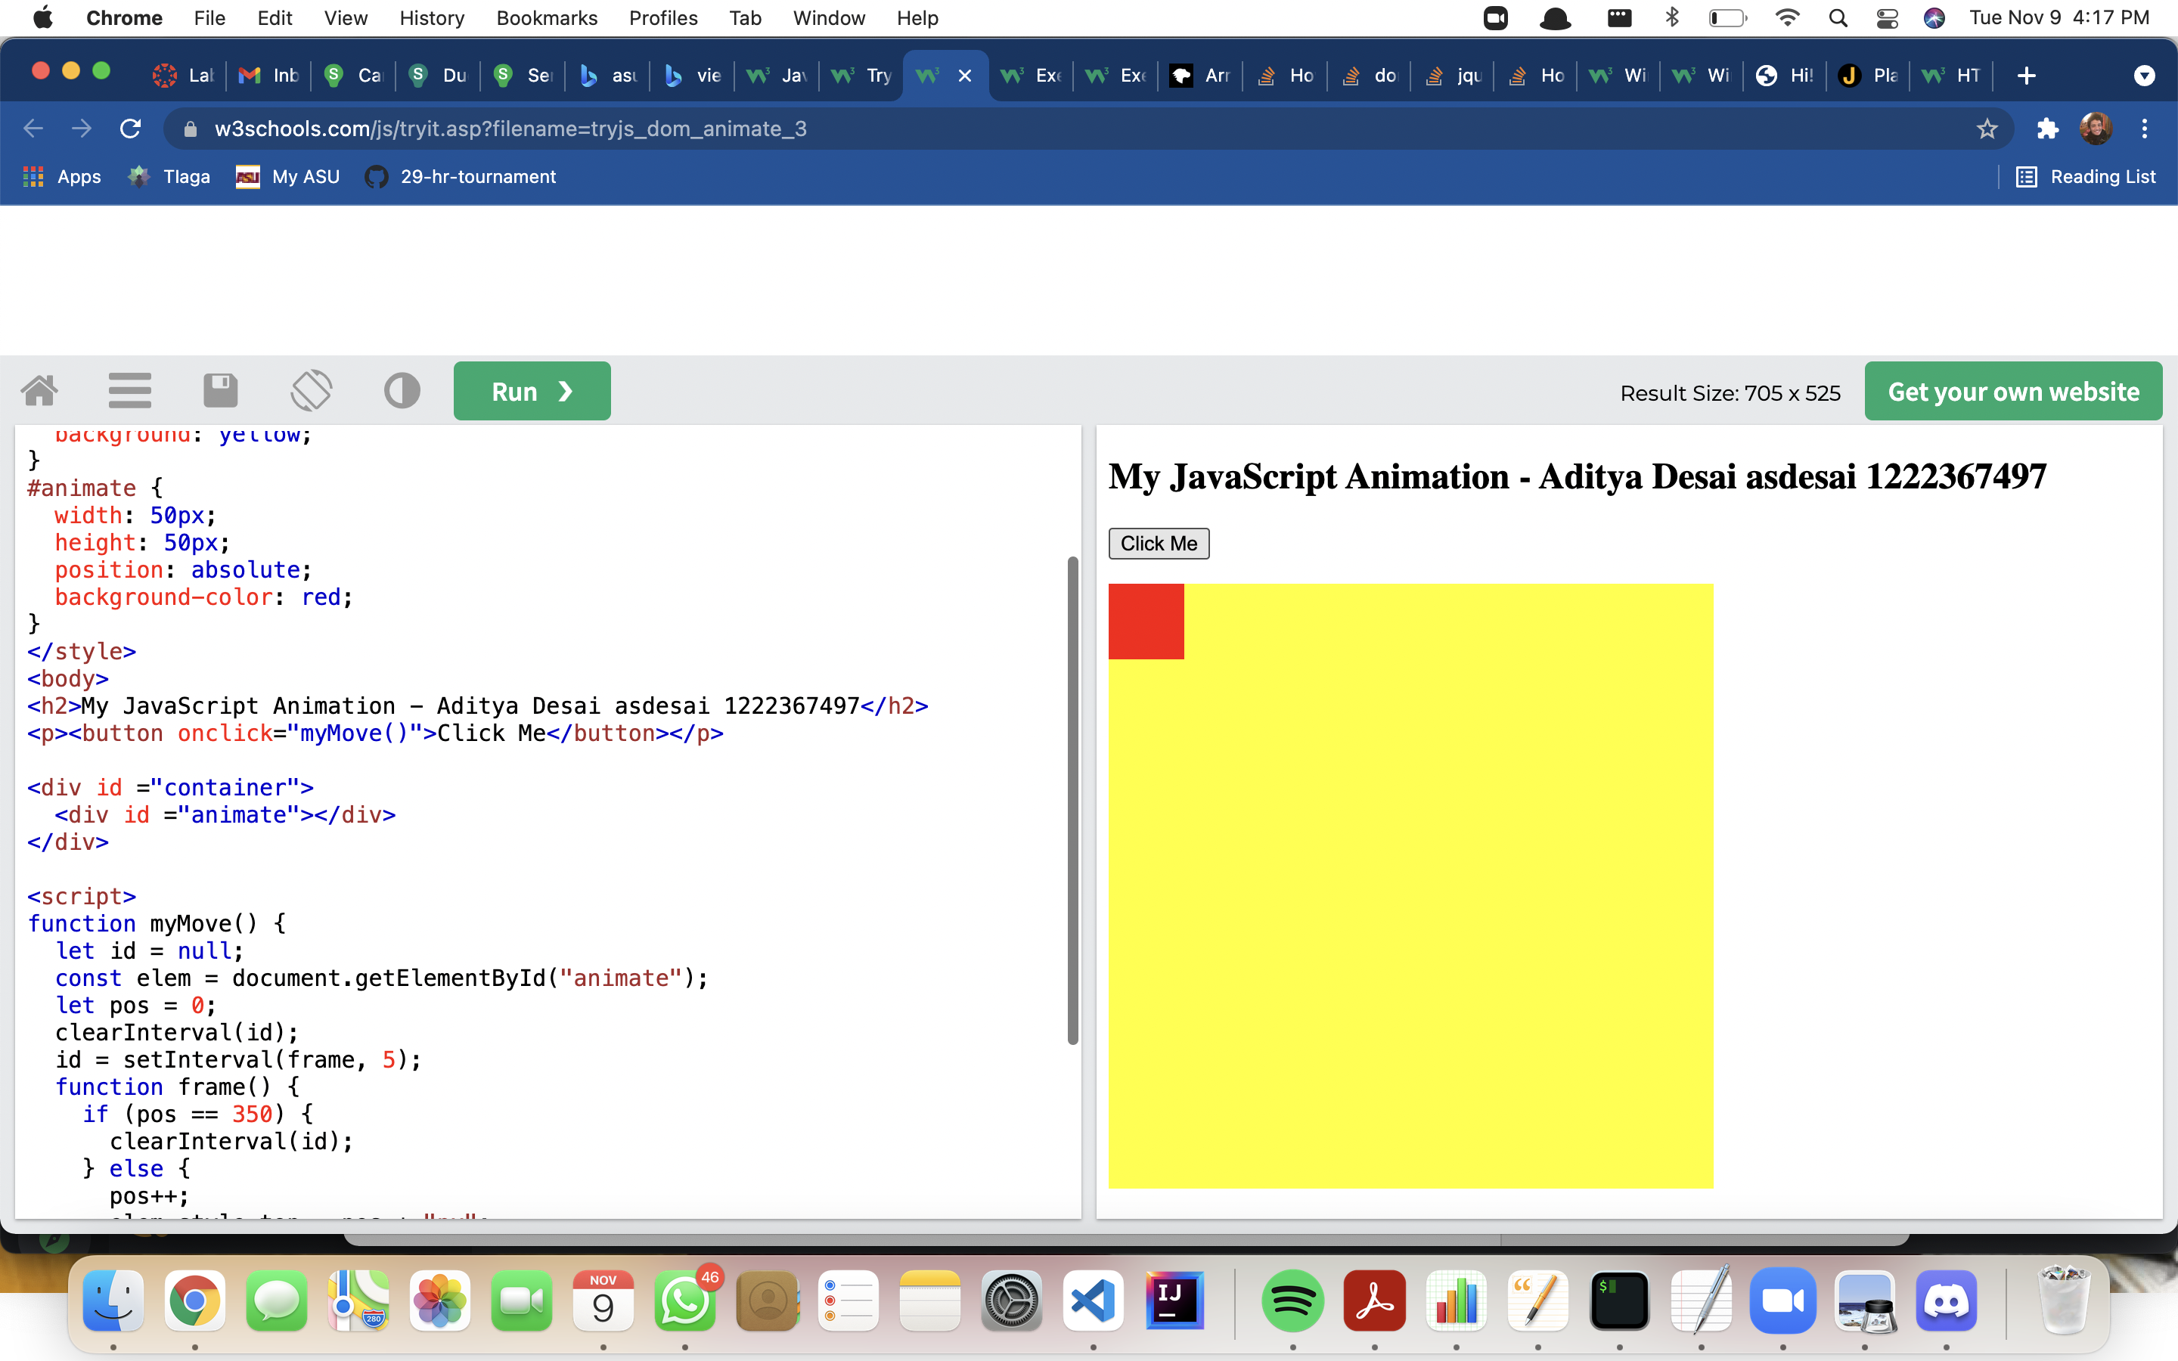

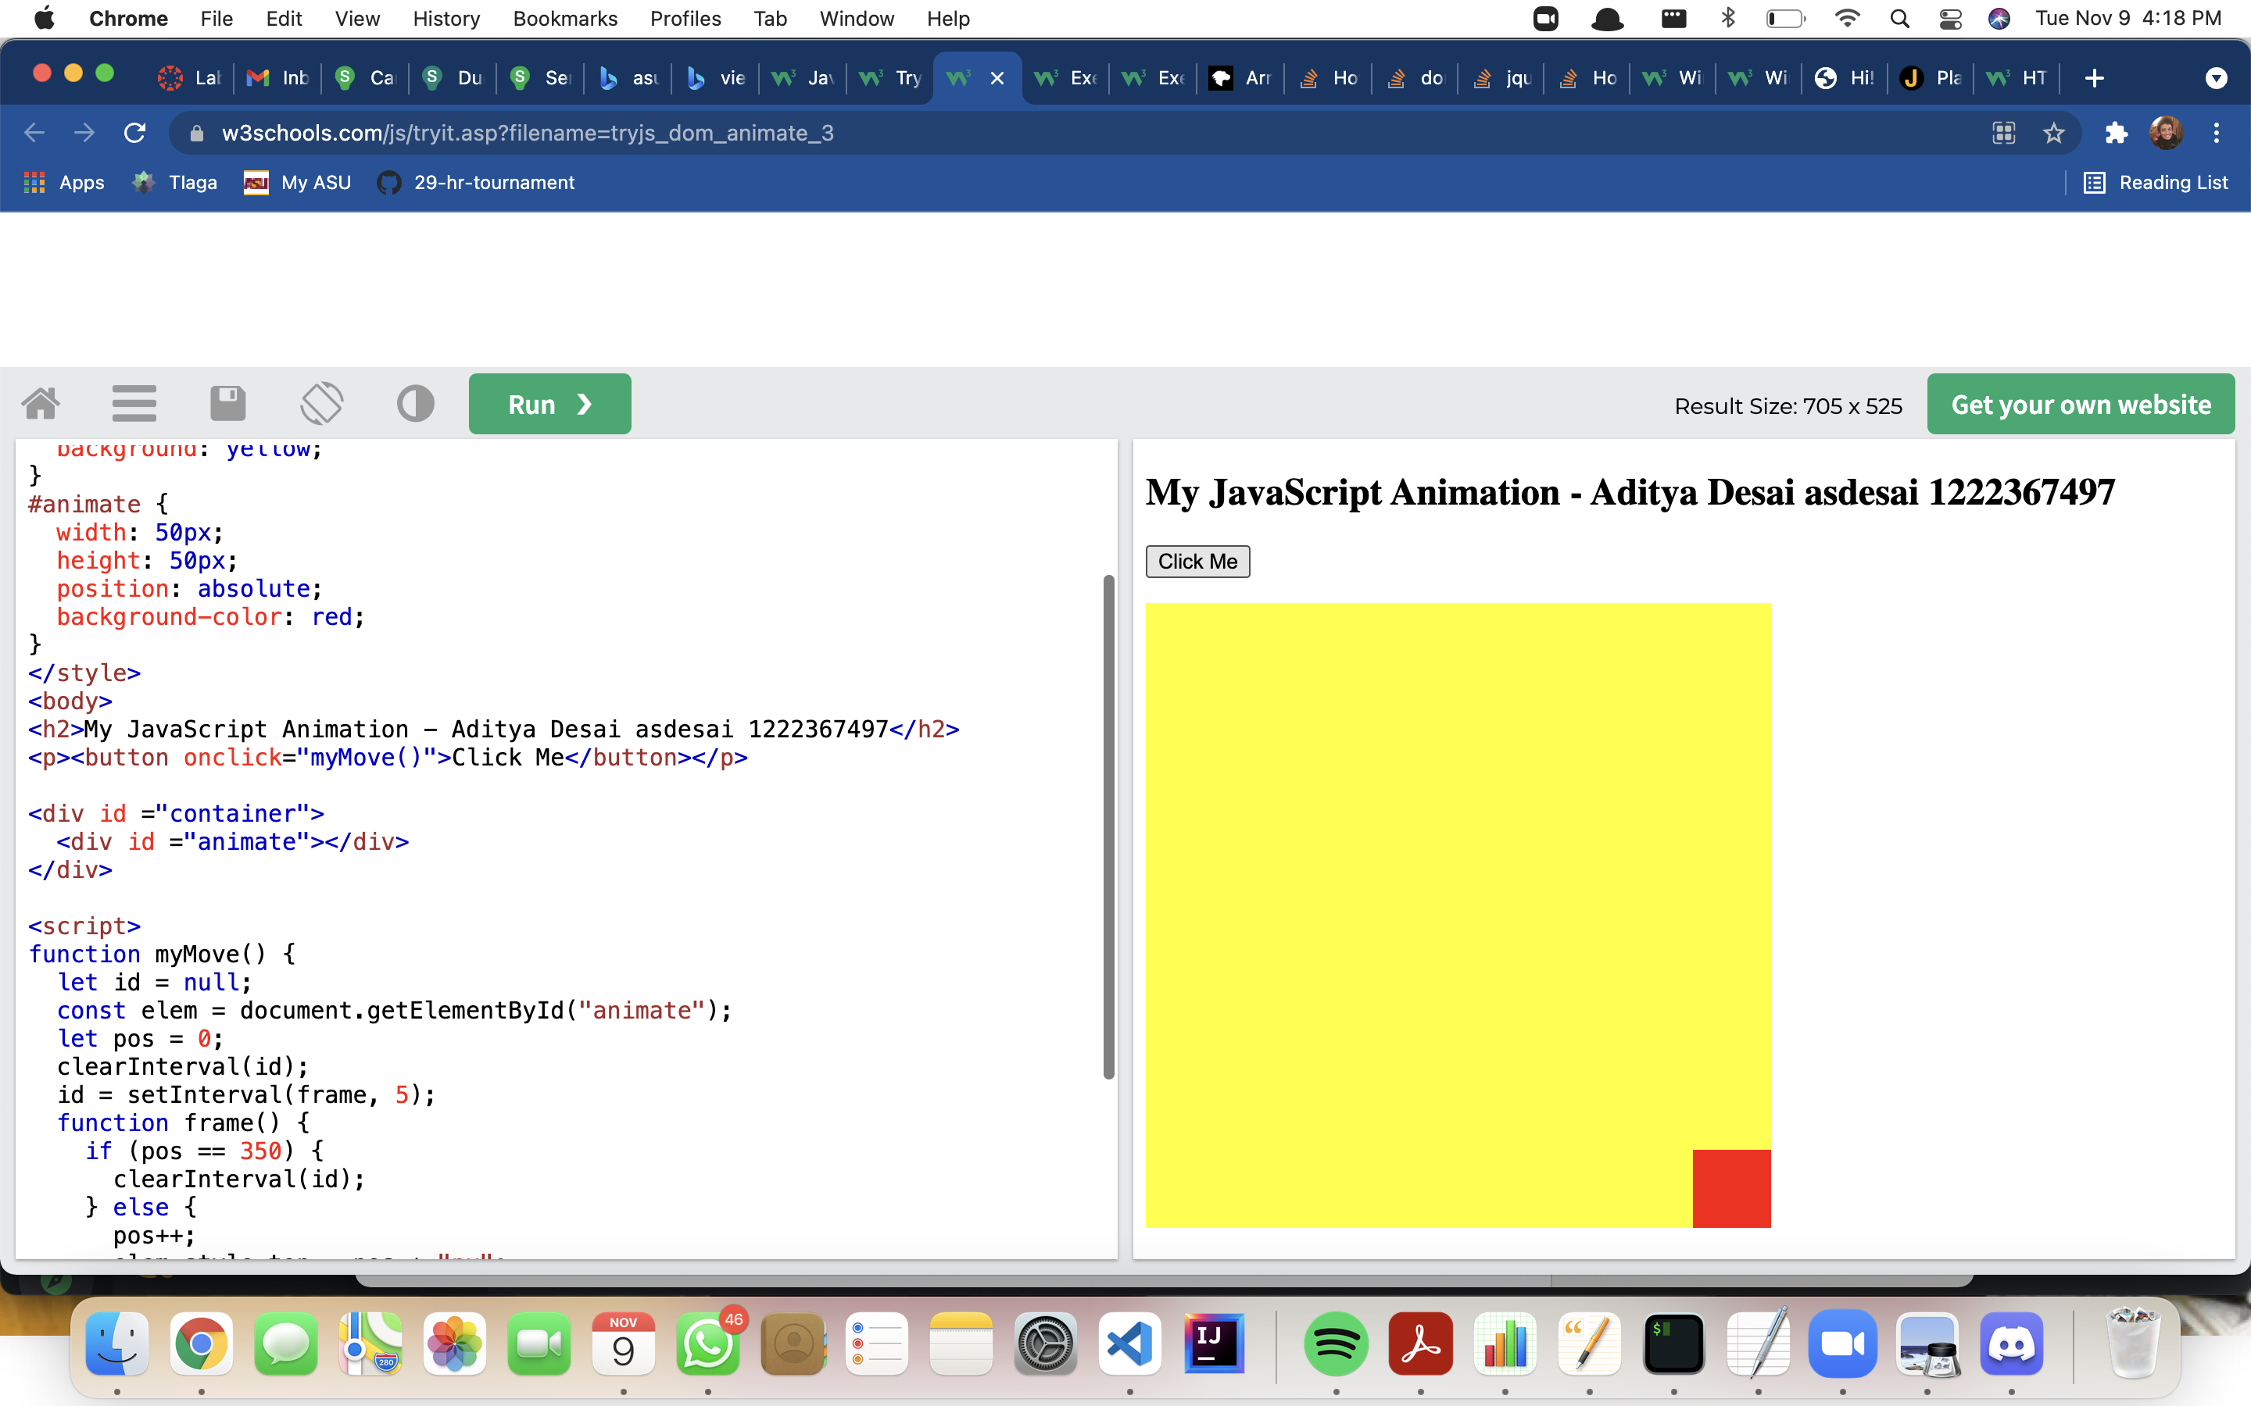18. <https://www.w3schools.com/js/tryit.asp?filename=tryjs_event_onclick2>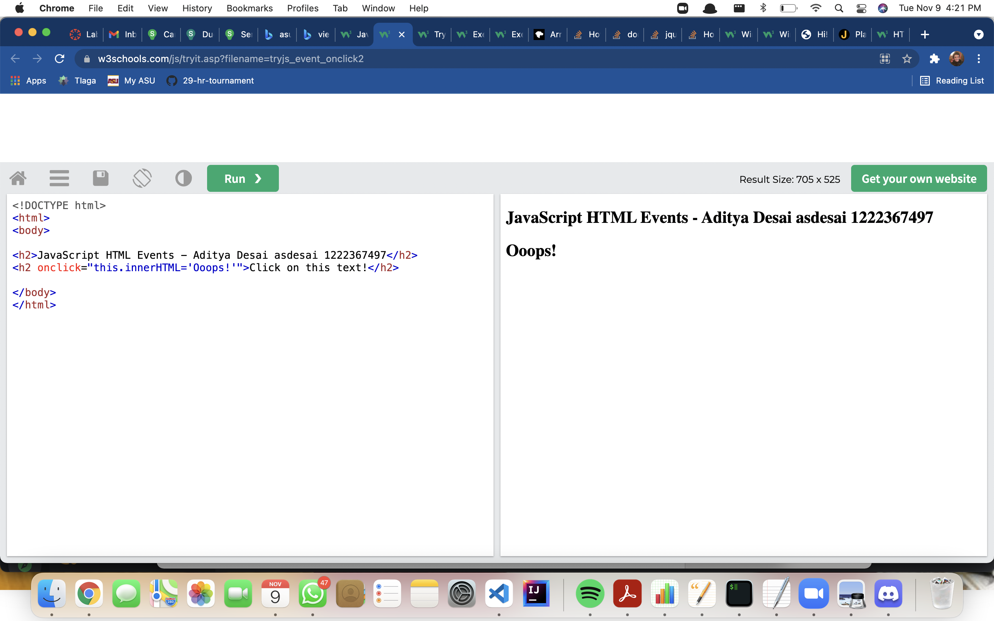

19. https://www.w3schools.com/js/tryit.asp?filename=tryjs_event_onclick3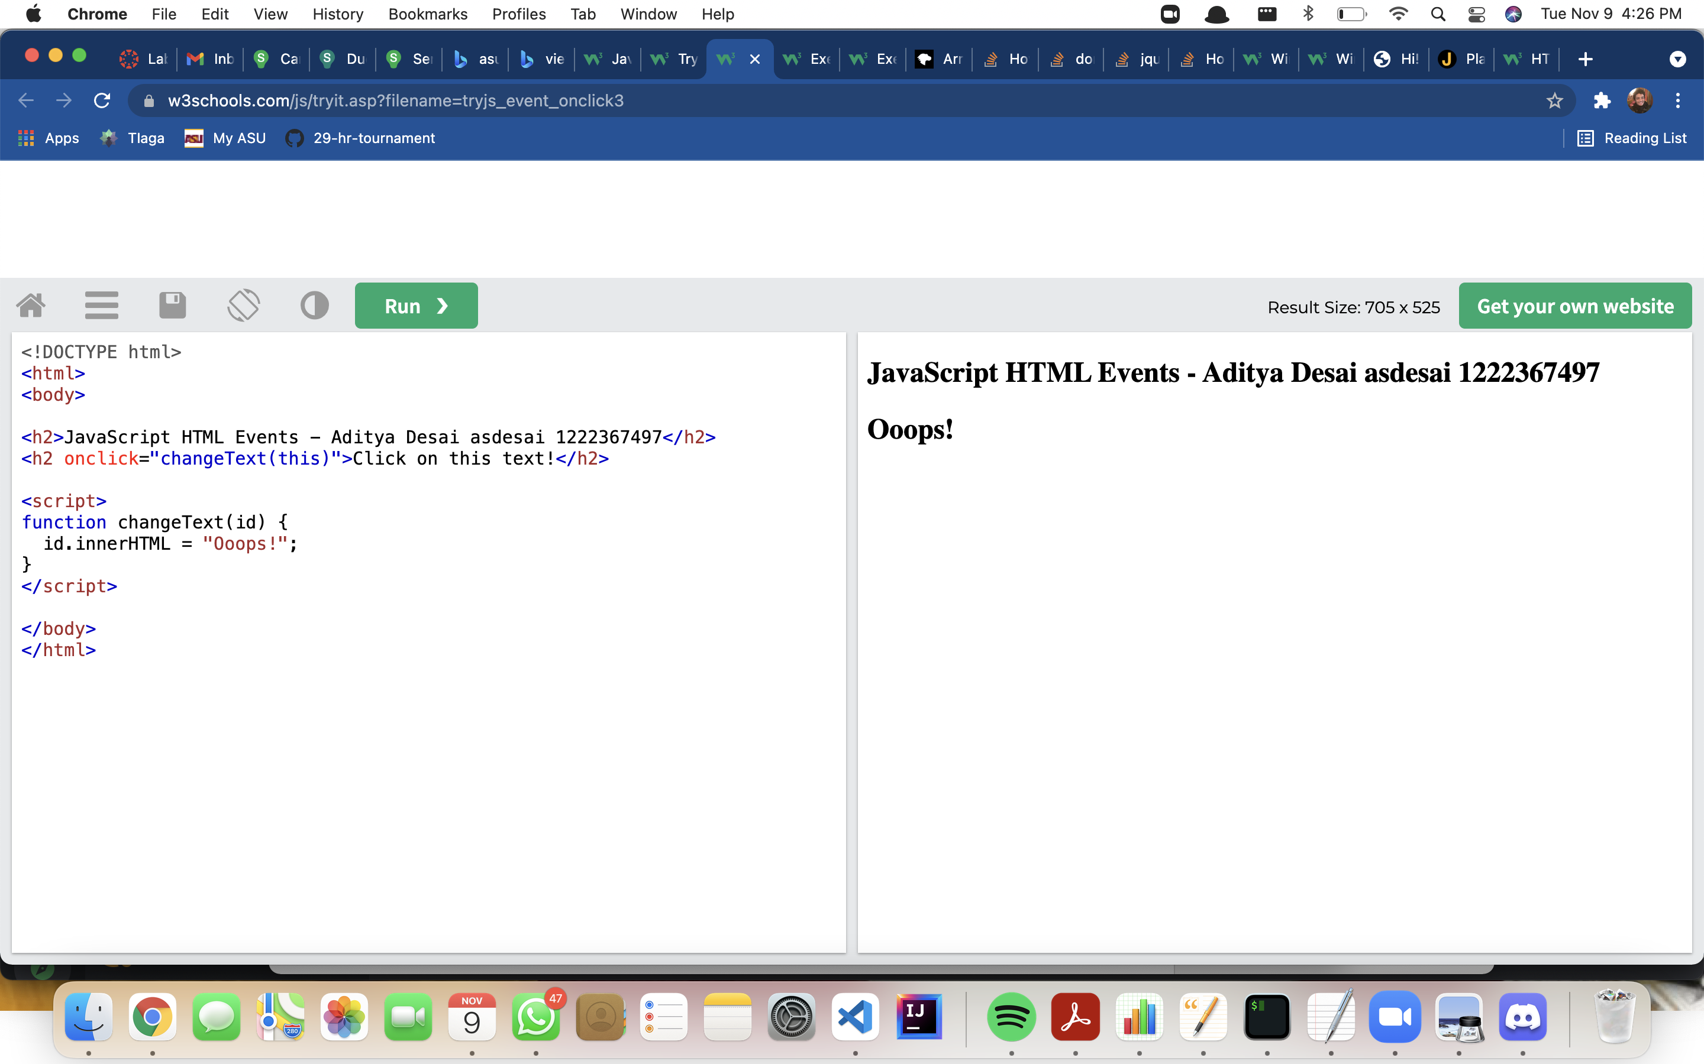

20. <https://www.w3schools.com/js/tryit.asp?filename=tryjs_events1>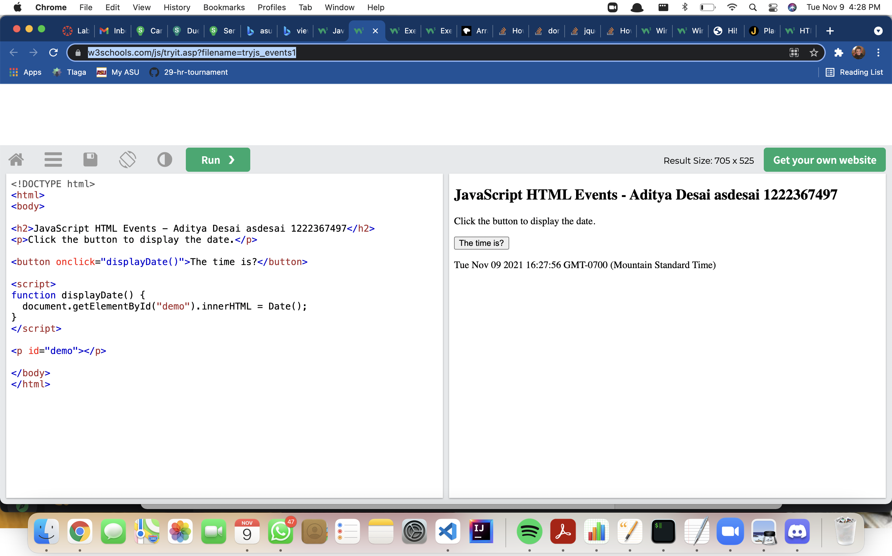

21.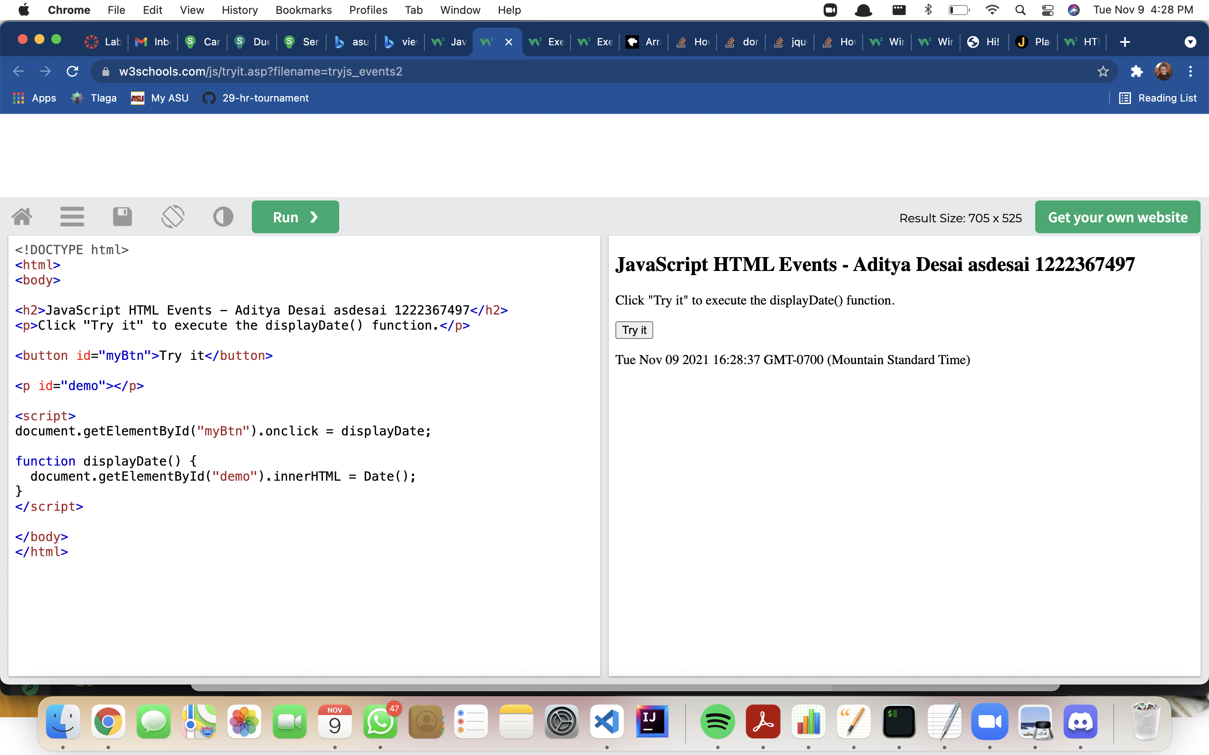 https://www.w3schools.com/js/tryit.asp?filename=tryjs_events2

22. https://www.w3schools.com/js/tryit.asp?filename=tryjs_events_onload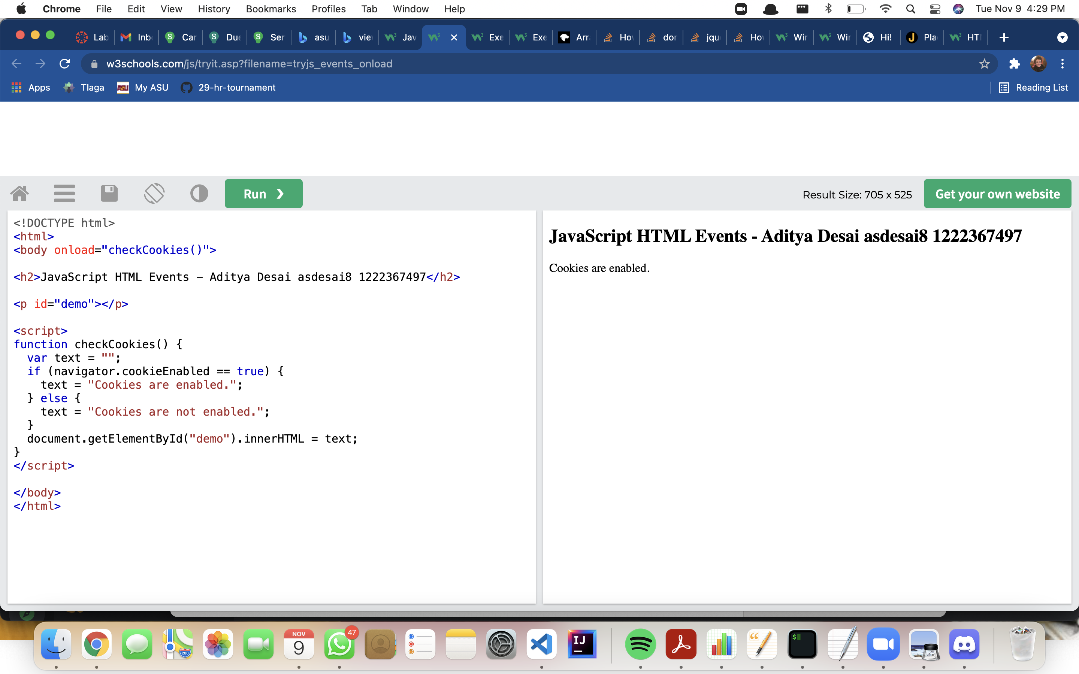

23. <https://www.w3schools.com/js/tryit.asp?filename=tryjs_events_onchange>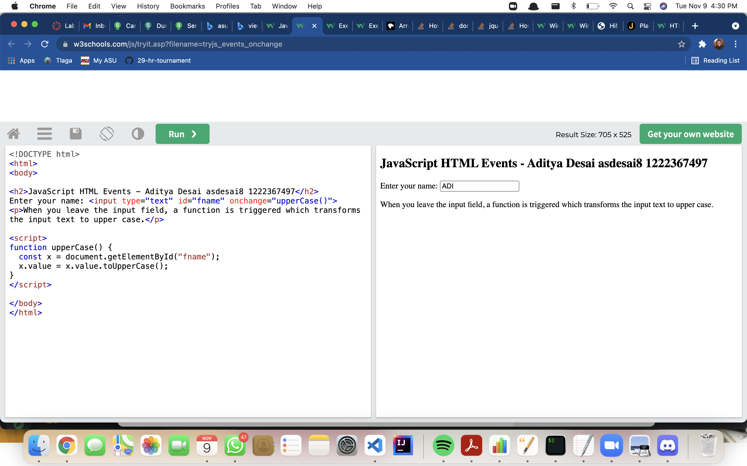

24. <https://www.w3schools.com/js/tryit.asp?filename=tryjs_events_mouseover>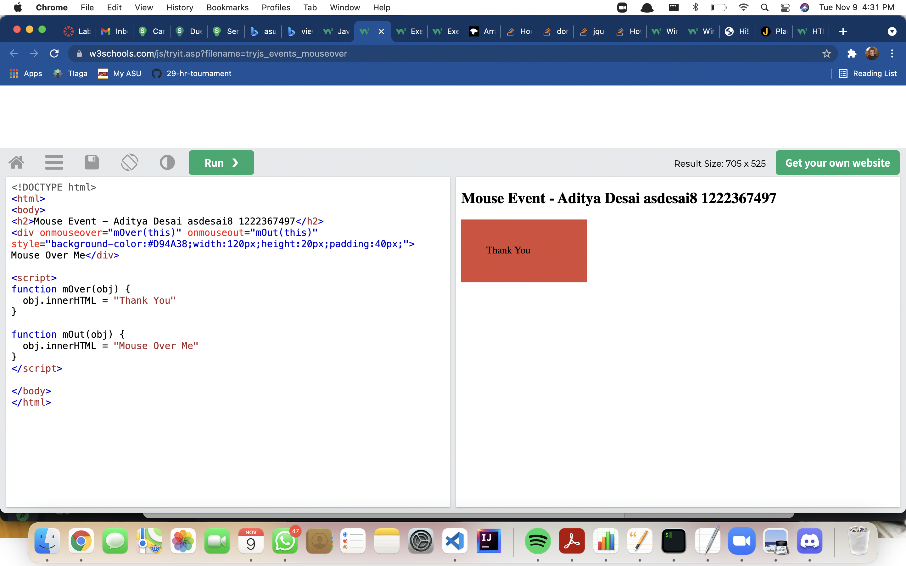

25.https://www.w3schools.com/js/tryit.asp?filename=tryjs_events_mousedown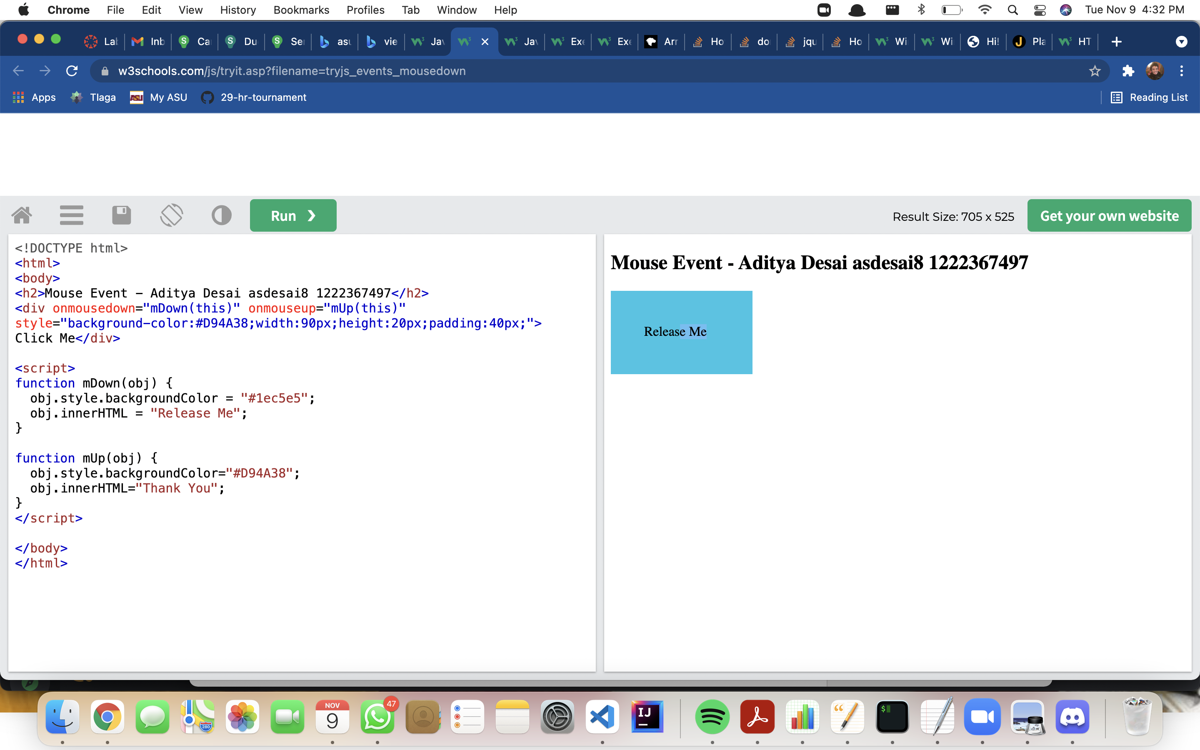

26. <https://www.w3schools.com/js/tryit.asp?filename=tryjs_addeventlistener_displaydate>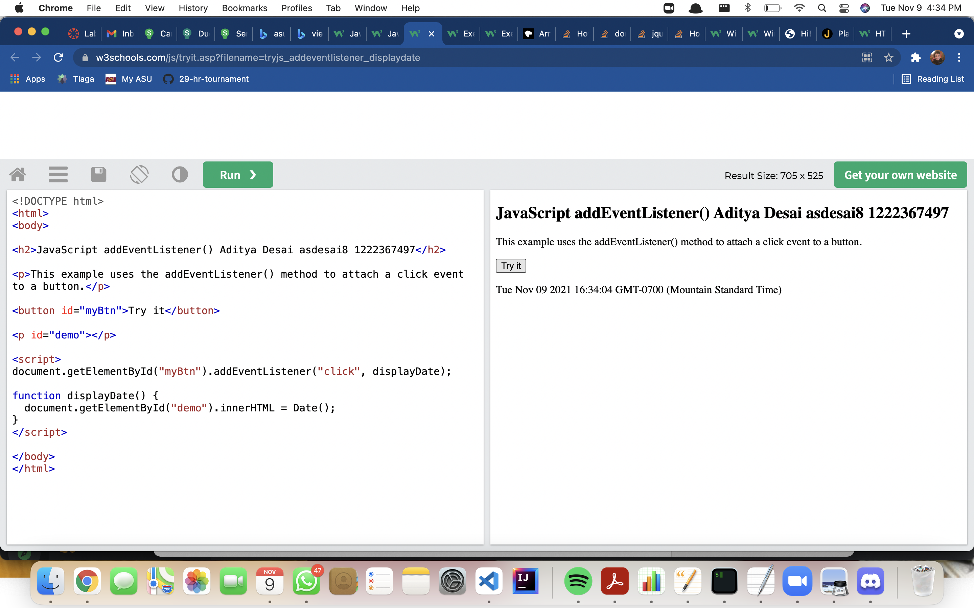

27. <https://www.w3schools.com/js/tryit.asp?filename=tryjs_addeventlistener_add>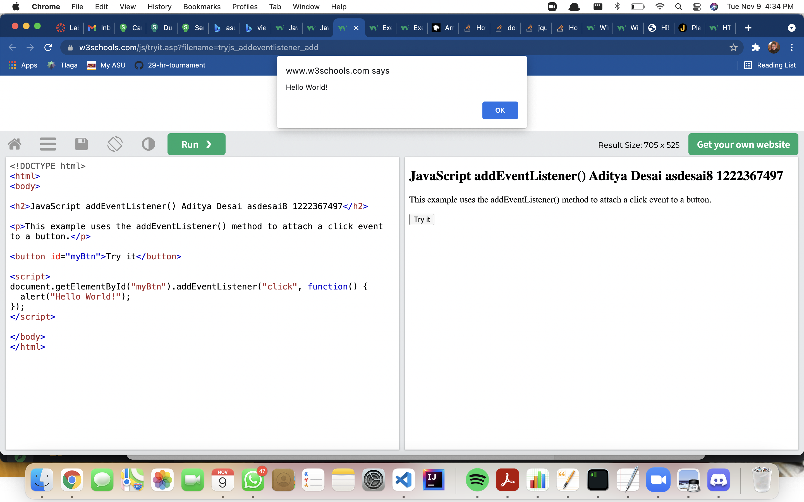

28.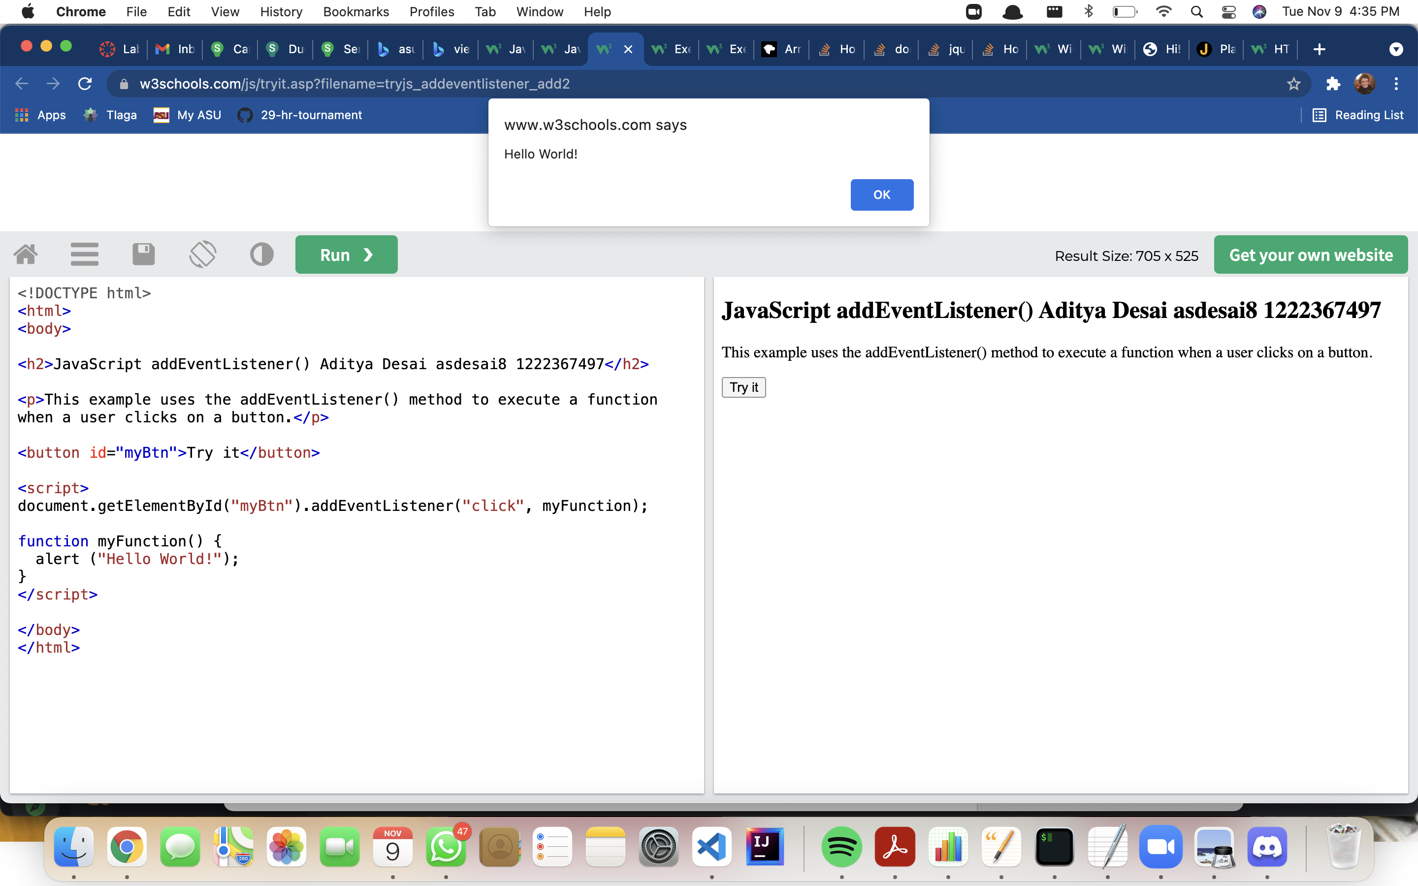 https://www.w3schools.com/js/tryit.asp?filename=tryjs_addeventlistener_add2

29. <https://www.w3schools.com/js/tryit.asp?filename=tryjs_addeventlistener_add_many>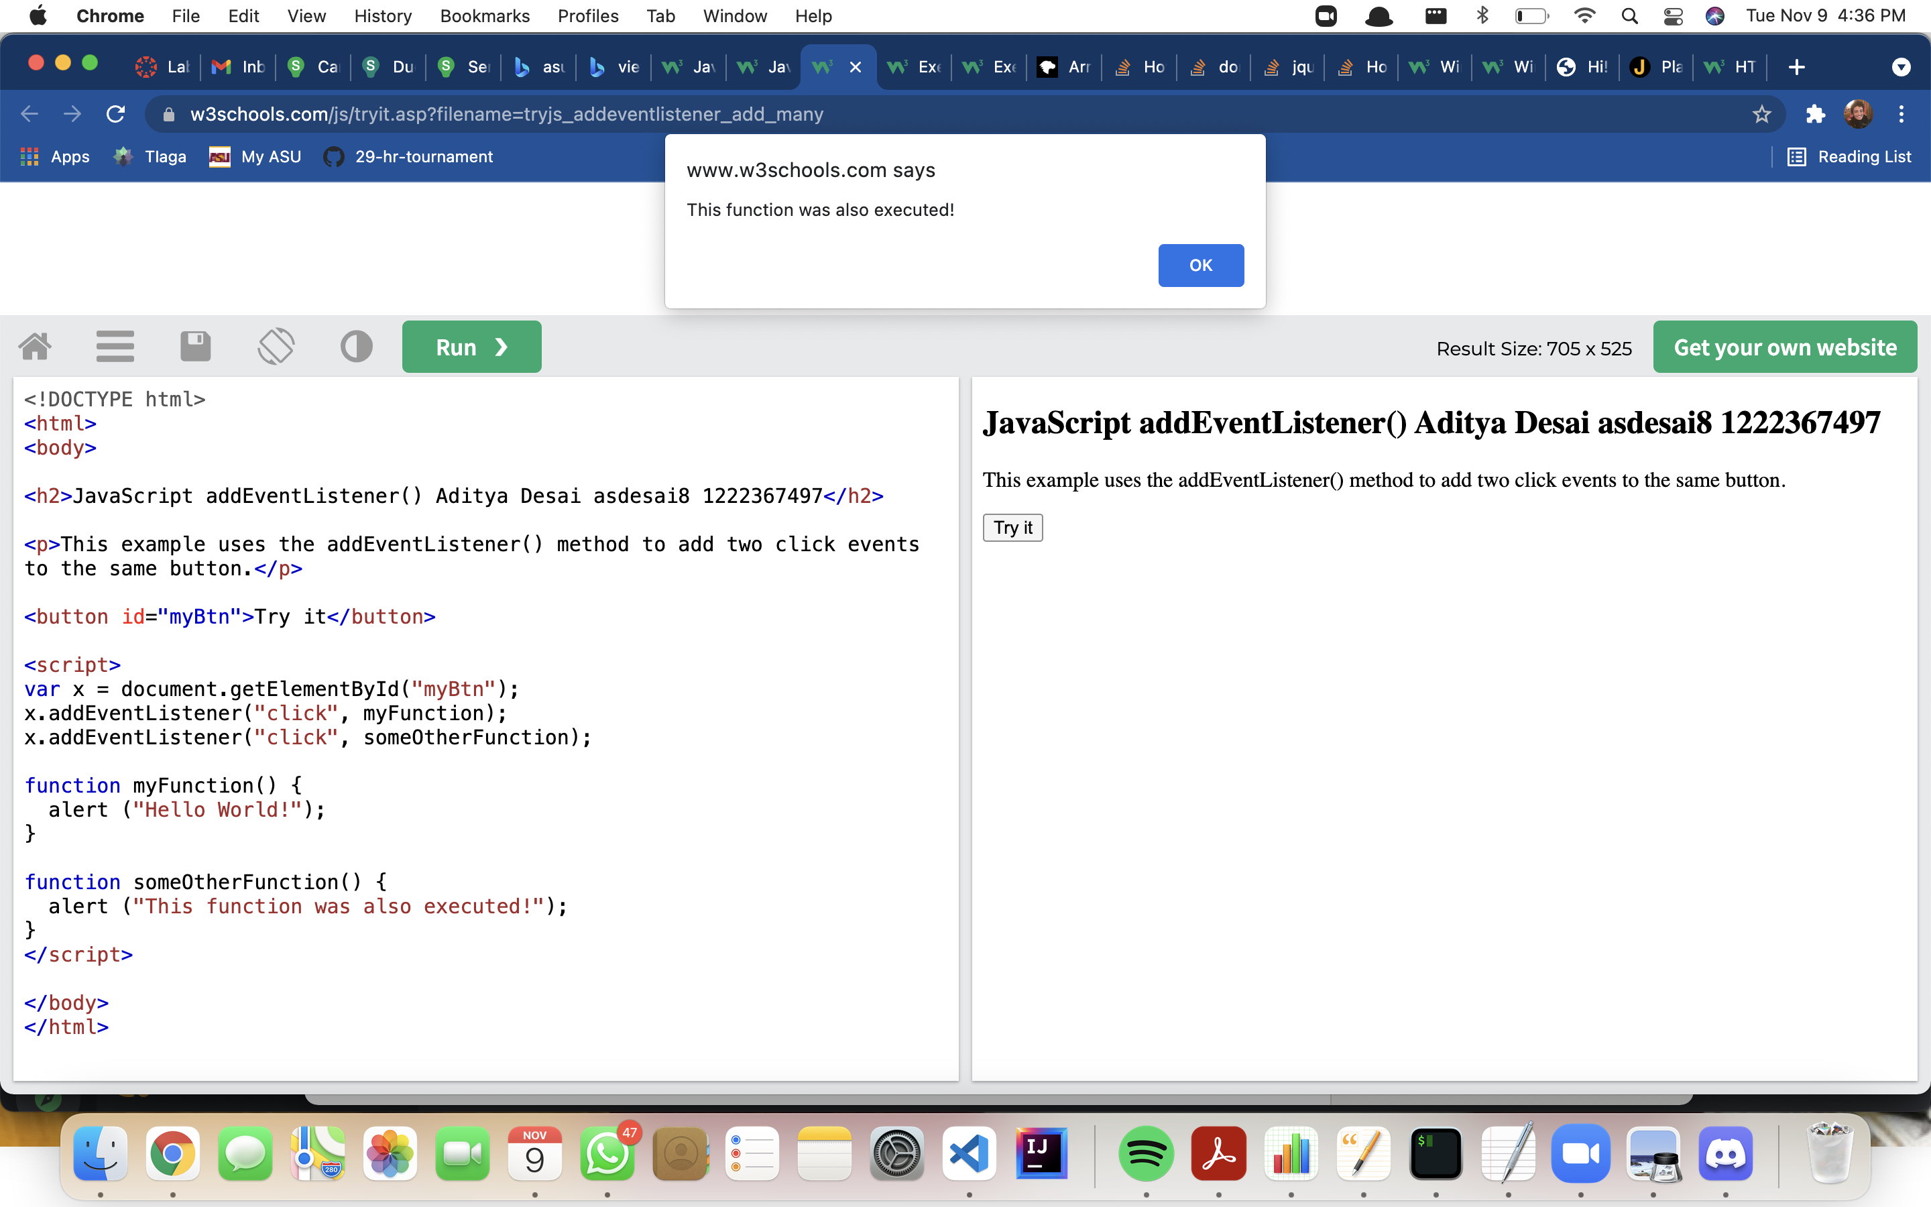

30. <https://www.w3schools.com/js/tryit.asp?filename=tryjs_addeventlistener_add_many2>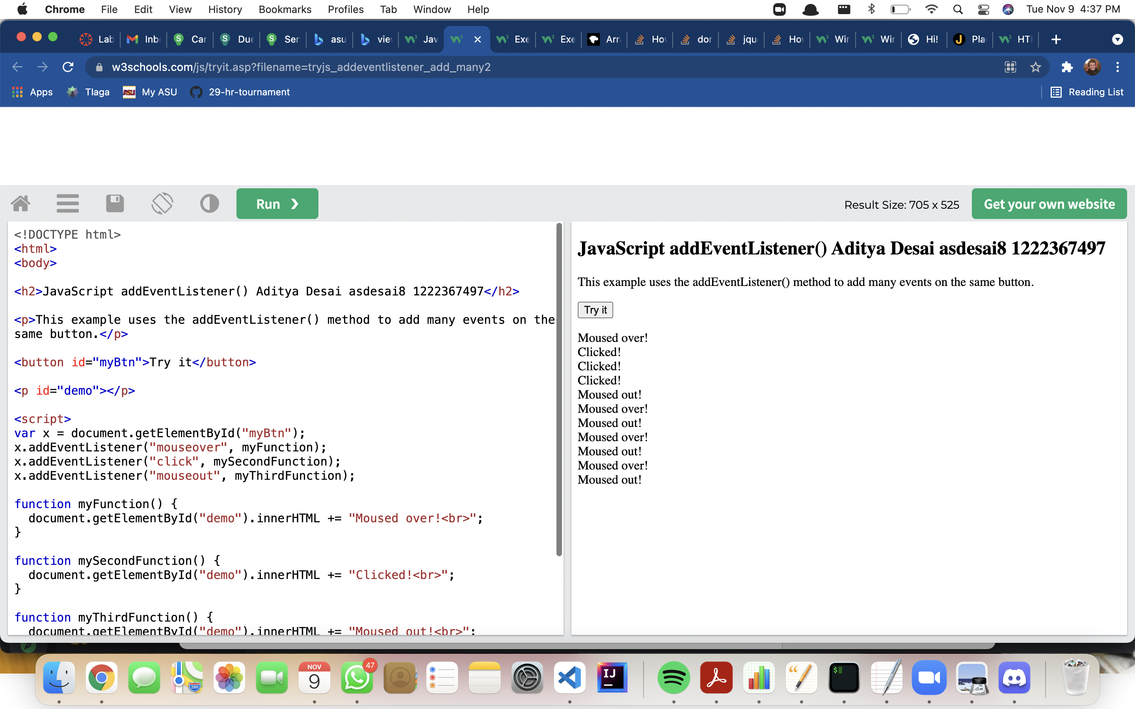

31. <https://www.w3schools.com/js/tryit.asp?filename=tryjs_addeventlistener_dom>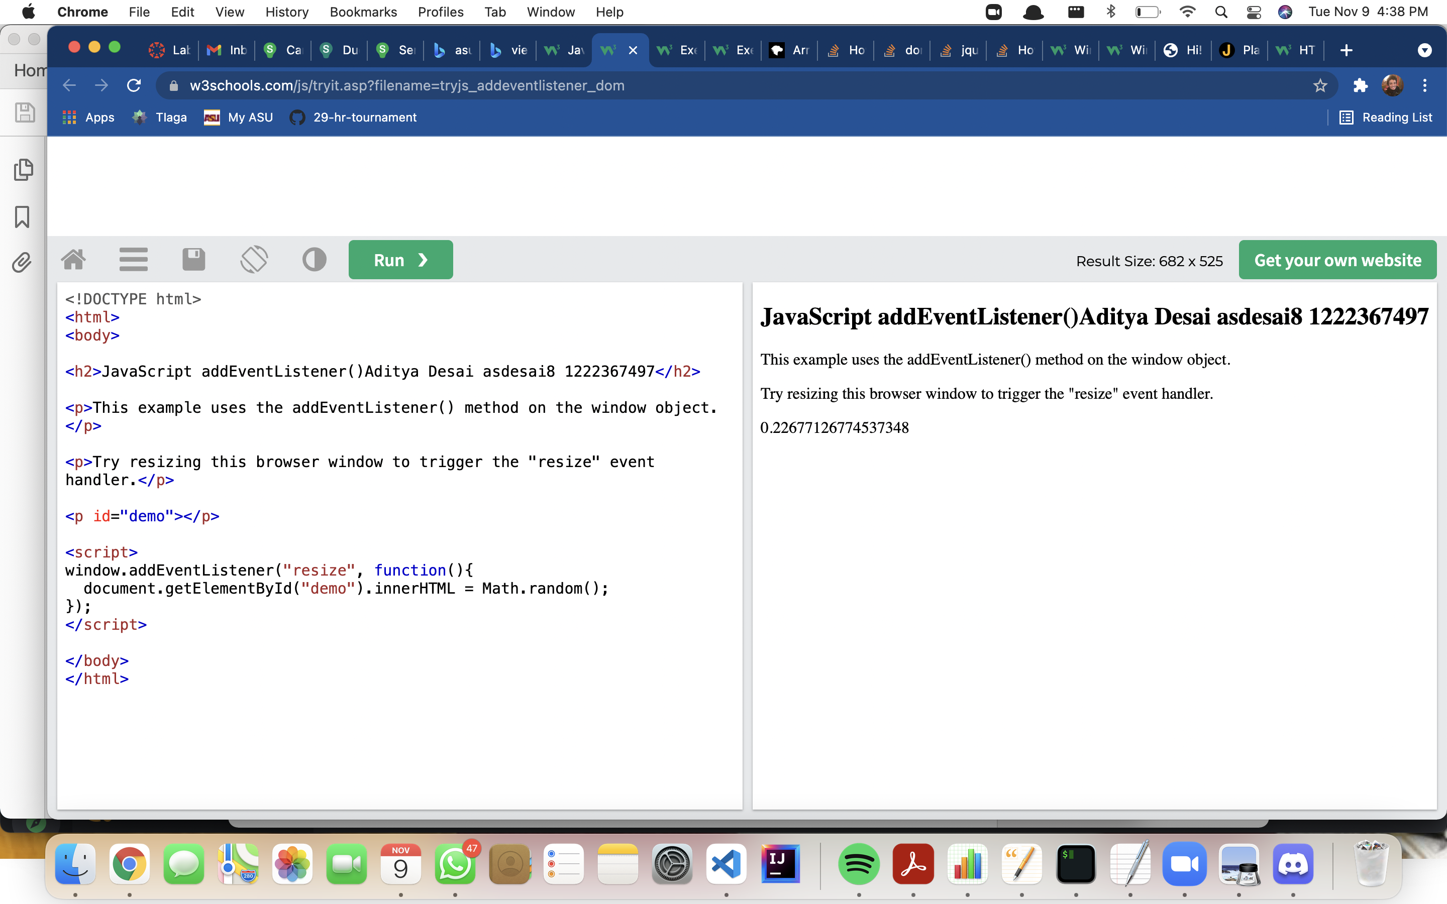

32. <https://www.w3schools.com/js/tryit.asp?filename=tryjs_addeventlistener_parameters>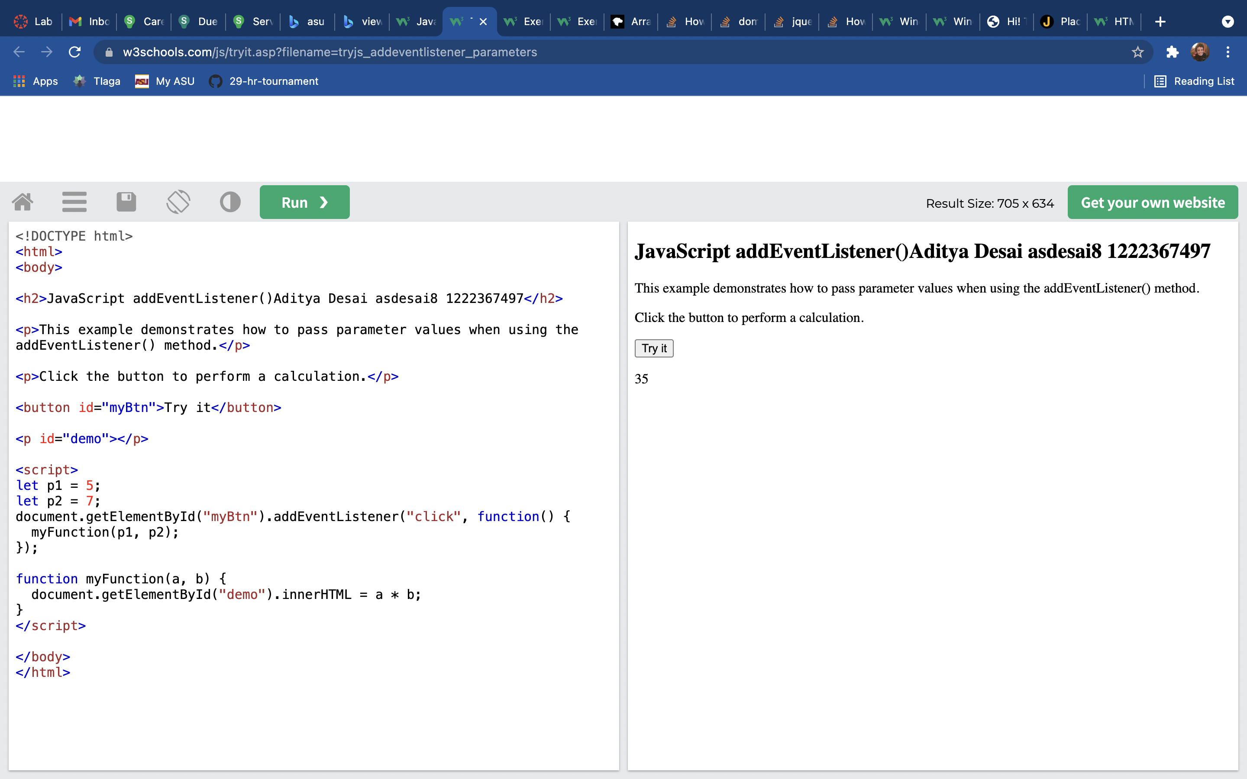

33. <https://www.w3schools.com/js/tryit.asp?filename=tryjs_addeventlistener_usecapture>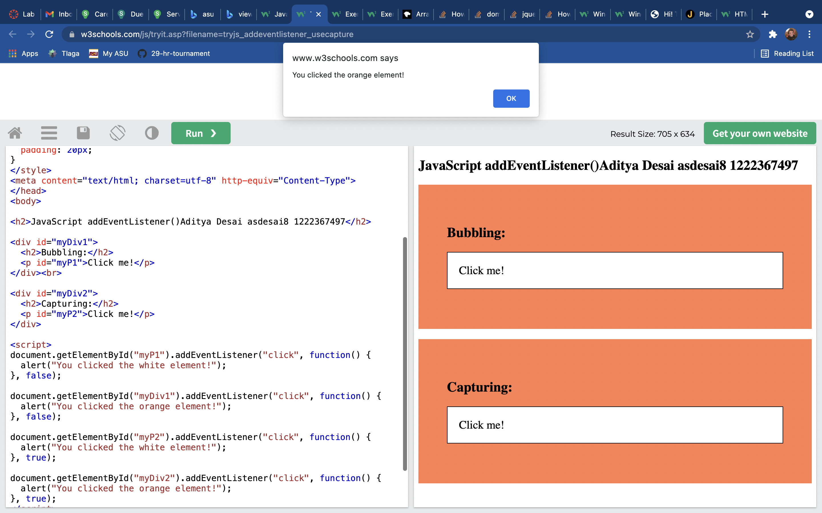

34.https://www.w3schools.com/js/tryit.asp?filename=tryjs_addeventlistener_remove